**DIGITAL MEDIA UNIT 2**

**CARIBBEAN ADVANCED PROFICIENCY EXAMINATIONS (C.A.P.E)**

**SCHOOL BASED ASSESSMENT**

**2016**



***TITLE OF PROJECT: A CRITICAL THINKING TOOL: E-LITRONL***

***NAME OF CANDIDATES: DEENAUTH MOHABEER, KEOMA DONALD GRANT, SONNY SIMON KOTHAPALLY***

***CANDIDATE NUMBERS: 0900410949***

***NAME OF SCHOOL: QUEEN’S COLLEGE***

***SCHOOL CODE: 090041***

***TERRITORY: GUYANA***

***TEACHER: MRS. SAMANTHA LIVERPOOL***

***DUE DATE: 1ST APRIL, 2016***

***TABLE OF CONTENTS***

***PART 1: RESEARCH AND PROPOSAL*** 3

**UNDERSTANDING THE CONCEPT** 4

**DESCRIPTION OF PRODUCT/PROJECT** 5

**DATA CAPTURE INSTRUMENT/TARGET AUDIENCE** 6

**DATA CAPTURE INSTRUMENT** 7

**DATA COLLECTION/DISTRIBUTION CHANNELS** 9

**ANALYSIS** 11

**DATA PRESENTATION** 13

**RATIONALE** 18

**PITCH** 19

**PROJECT OVERVIEW** 21

**CONCEPT (DRAFT DESIGNS)** 22

**METHODOLOGY, TOOLS, TECHNIQUES** 27

**BUDGET** 29

***PART 2: PROGRESS AND PROCESS*** 30

**TIMELINE** 31

**MILESTONE CHART** 32

**PRODUCTION SCHEDULE** 33

**SCRIPTS FOR STORYBOARD** 35

**MOCK-UPS** 38

**NAMING THE PROPOSED PRODUCT** 42

**STORYBOARD CONCEPT** 43

**BASIC STORYBOARD** 44

**WIREFRAMES** 56

**PRODUCTION OF WIREFRAMES** 59

**ANIMATIC** 60

**PROJECT OUTLINE** 66

**BRAINSTORMING CHART** 69

**FINAL MODELS/ PROPS/ASSETS/FINAL CONTENT** 72

**HYPER TEXT MARK-UP LANGUAGE (HTML) MOCK-UPS** 75

**HYPER TEXT MARK-UP LANGUAGE (HTML) – Code** 77

**CODE** 77

***PART 3: PRODUCT*** 82

**Interactive Product – E-Litronl – A Visualization Entity** 83

**GOOD USE OF COLORS AND TEXTURE** 90

**GOOD USE OF SPACE** 91

**GOOD USE OF TYPOGRAPHY** 92

**BIBLIOGRAPHY** 93

# ***PART 1: RESEARCH AND PROPOSAL***

## **UNDERSTANDING THE CONCEPT**

In the initial brainstorms for the concept, the idea was to implement an interactive literature journal to enhance literary levels in English B students at the CSEC level. This idea was existent in the groundwork during the first years of the project, as a component of the IA for Digital Media Unit 1. Coming into the second year of the project, further brainstorms led to a new idea. The idea was not only an interactive literature journal, but rather an entire class of digitally interactive products for multiple subjects. With this new idea as support, the project was then transformed into a **Critical Thinking Tool (CTT)**, with each subject having a digital tool to enhance the students’ writing, logic, and decision making skills.

However, initial estimates required more than the 1 year available to implement such an idea. These constraints lead the researchers to implement a subclass of the Critical Thinking Tool specialized for English B for the C.A.P.E. Digital Media programme. The subject English B was chosen as previous designs were specialised for English B.

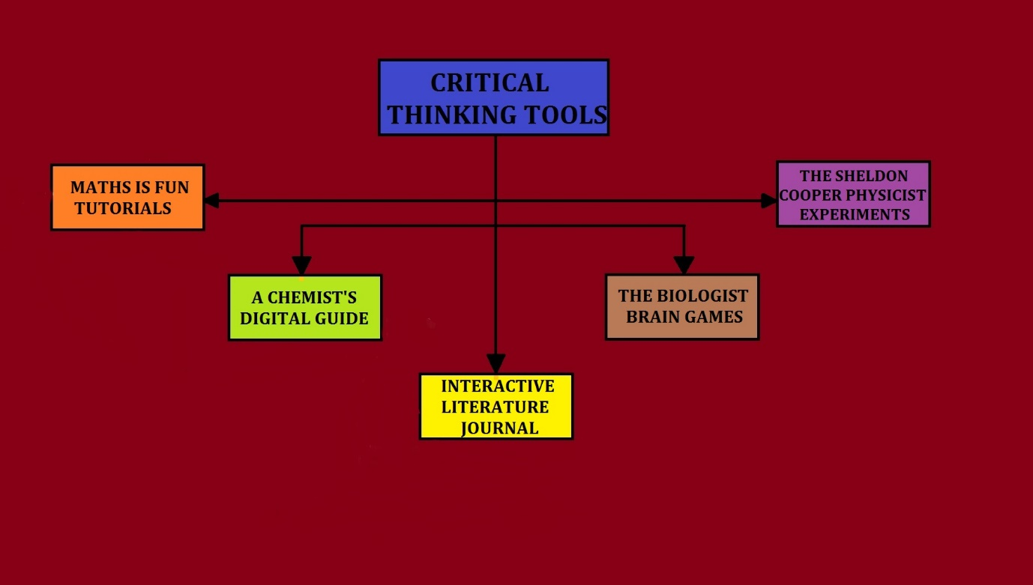

## **DESCRIPTION OF PRODUCT/PROJECT**

The product that will be produced is the **English Literature Interactive Journal**. This product is a digitally enhanced student/teacher media journal containing text, animation, music, voice-acting and graphics. This product focuses strongly on:

* The ability of students to respond to West Indian and other literatures in English such as novels, short stories, poems and plays; to draw rational and sensitive conclusions, literary states of consciousness and other concepts explored in literature; and to relate the same to everyday living.
* The ability to communicate informed opinions and judgments in well-structured, analytical responses in oral and written form pertaining to literature.
* The provision of quality education to less fortunate students who cannot attend extra lessons.
* The means to serve as a platform for Caribbean students to achieve universal secondary education, as the researcher hopes to implement Interactive guides for all subject areas.
* The ability to analyse effectively, poems, plays and other forms of literature; to understand the message of these literature art forms.

## **DATA CAPTURE INSTRUMENT/TARGET AUDIENCE**

An online survey development cloud-based software service known as “SurveyMonkey” was used to design the data capture instrument. The service provided free editable surveys, as well as a range of paid backend programs that include data analysis, sample selection, bias elimination and data representation tools. The researchers decided on this method mainly because:

* It allowed for large amounts of information to be collected from a large quantity of individuals in a short period of time and in a cost efficient manner.
* It allowed for clear and concise analysis of data.
* It allowed for comparison and contrast of the gathered information.

The questionnaire consisted of ten structured questions which were distributed to fifty (50) students of Queen’s College, Georgetown in the Co-operative Republic of Guyana**.** These candidates consisted of pre and post CSEC candidates. The researchers chose this audience because the product is being supplied to this group of candidates.

The researchers intend to distribute the product via the Interactive PDF format more commonly known as PDF 2.0. The target audience will be focused on Caribbean students sitting the Caribbean Secondary Education Certificate Examinations (CSEC). In addition to CSEC, students from lower levels can use this product as it would provide a great deal of information to them.



## **DATA CAPTURE INSTRUMENT**

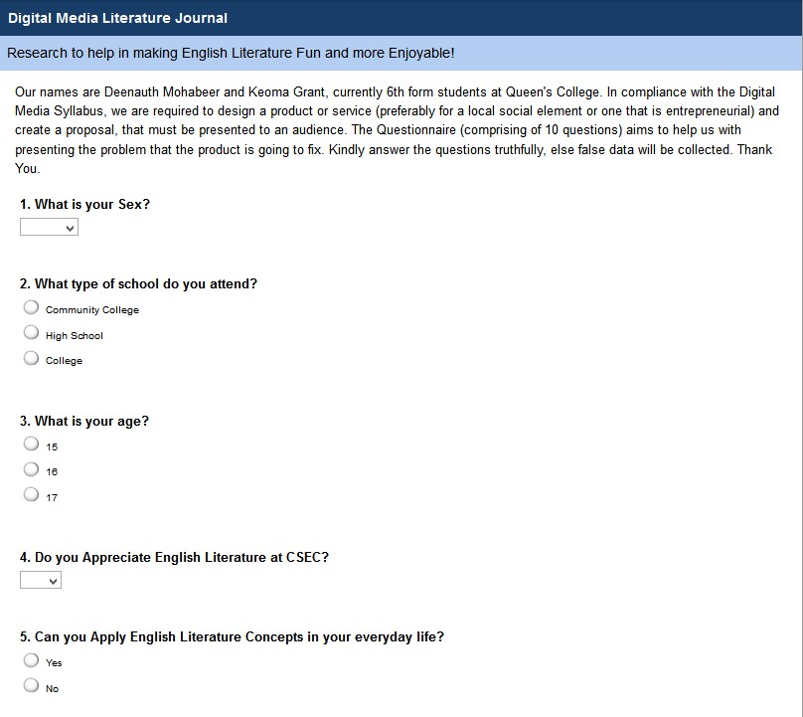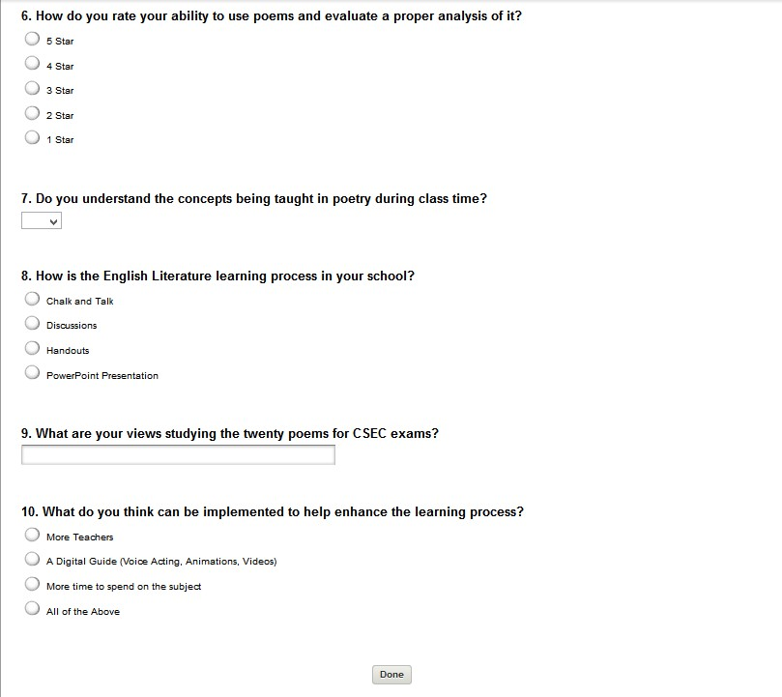

## **DATA COLLECTION/DISTRIBUTION CHANNELS**

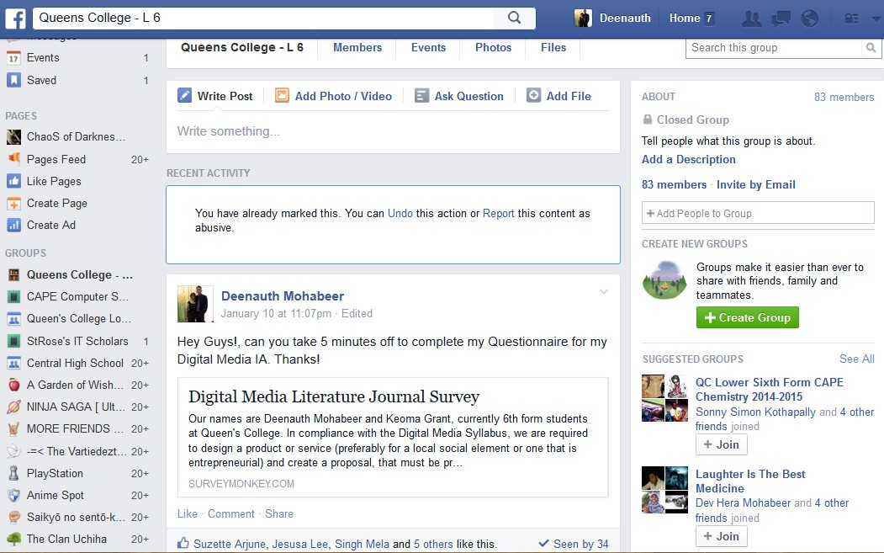

Fig. 1.0 Snapshot showing data collection method 1 through Facebook

One of the data collection methods was through the popular social networking site Facebook. In particular, a Queen’s College Guyana Interactive Group for Lower 6 and 5th form students were asked to complete the questionnaires. Thirty (38) persons answered the questionnaires from the web link (Facebook Group) during the two (2) day duration of the survey.

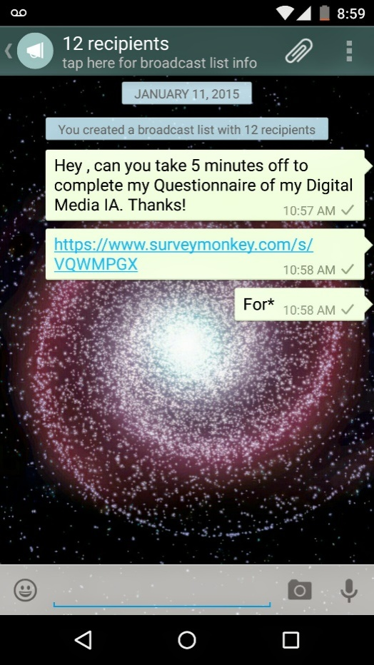

Fig. 1.1 Snapshot showing data collection method 2 through ‘WhatsApp’

The Second data collection method was used through a social messaging platform known as “WhatsApp”. Twelve persons were distributed questionnaires in this way.

## **ANALYSIS**

The respondents of the questionnaire constituted three-fifths (60%) of females and the two-fifths (40%) of males. Respondents were identified as being from *high schools* (62%), *colleges* (36%) and from *community colleges* (2%). The majority of respondents were of age seventeen (62%); minorities – age sixteen (36%) and age fifteen (2%) in the total poll. Numerous respondents (76%) stated that “they appreciate English Literature at the CSEC level” whereas as the remainder (24%) of respondents stated that “they don’t appreciate the subject”. Furthermore, a majority of respondents (52%) said that they cannot apply literature in their everyday life unlike the minority (48%) who said that they can. On further study, respondents asserted that students can analyse a poem: at a moderate level (42%), at a good level (18%), at an excellent level (16%), at a poor level (12%) and at a very poor level (12%). The researchers then conjectured that students do understand literature concepts but have difficulty in expressing and analysing the poem, failing to evaluate possible solutions to literary questions.

Respondents were asked if they understood the concepts being taught during class time. Again a marginal majority (54%) said yes, and the remainder (46%) said no. A bulk of the population said that the current medium for teaching literature is through **discussion** (56%), others saying **“Chalk and talk”** (42%) and one particular respondent highlighting the use of **PowerPoint Presentations** (2%). The researchers then concluded that students understood the concepts through various teaching methods but however failed to apply these concepts.

The next question then asked respondents to express their views on studying twenty (20) poems for the CSEC examination. The bulk of responses were negative (“Tough, hard, pointless etc.”) while others indicated that “they loved literature, so it’s easy for them”, while others said its”. Other responses include “tough but the time period is inadequate to study them (2 years)”, “themes can be grouped”. The final question asked respondents about improving the learning process. A huge margin of responses preferred a **digital guide** which gathered most (66%) of the responses, while others (26%) opted for all the options available, spend more class time (6%) and opting for more teachers (2 %). So basically, students are finding it difficult to study twenty poems using the current teaching methods (Discussion, Chalk and talk etc.), and are eager for an external source (like a **digital guide**) to help them understand and conceptualize literature in all its profundity.

## **DATA PRESENTATION**

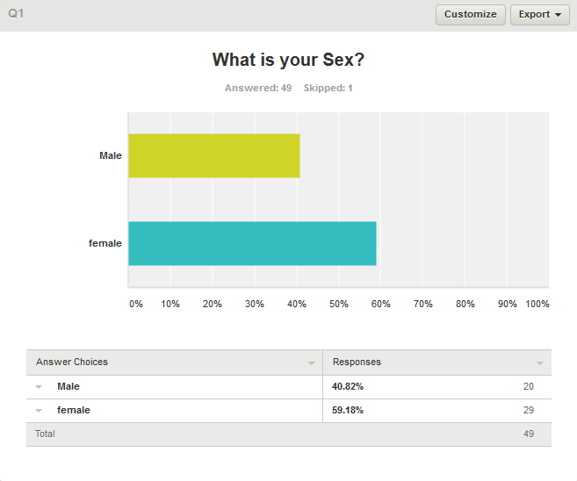

Fig. 2.0: Bar graph showing the age distribution of respondents

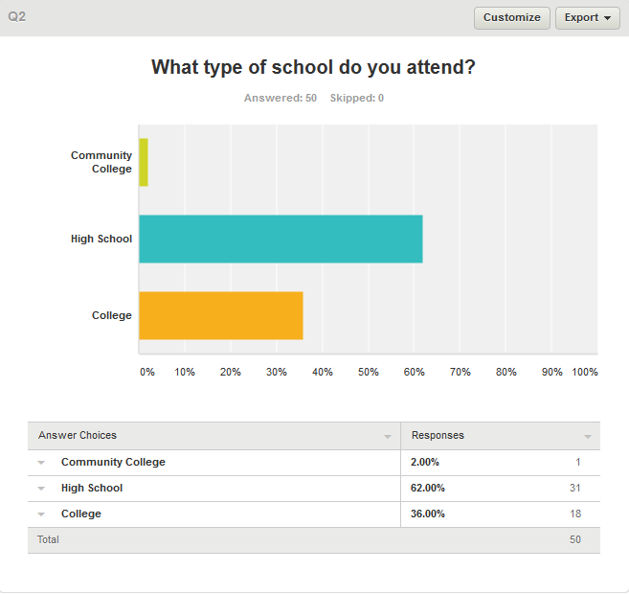

Fig. 2.1: Bar graph showing the schooling responses given by respondents

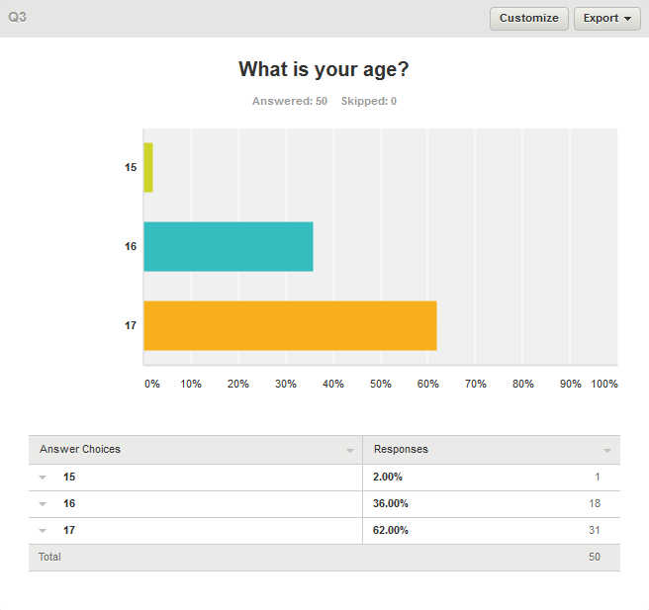

Fig 2.3: Bar graph showing respondents’ age proportions.

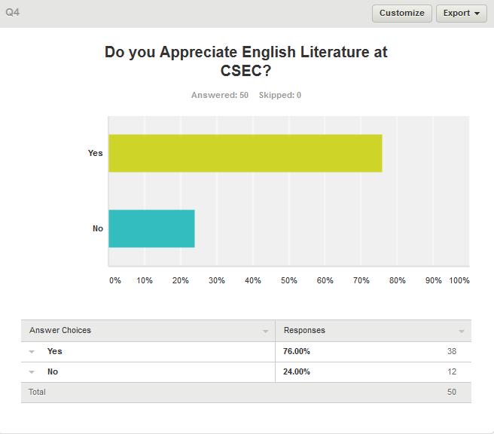

Fig 2.4: Bar graph showing respondents who appreciate literature and those who don’t.

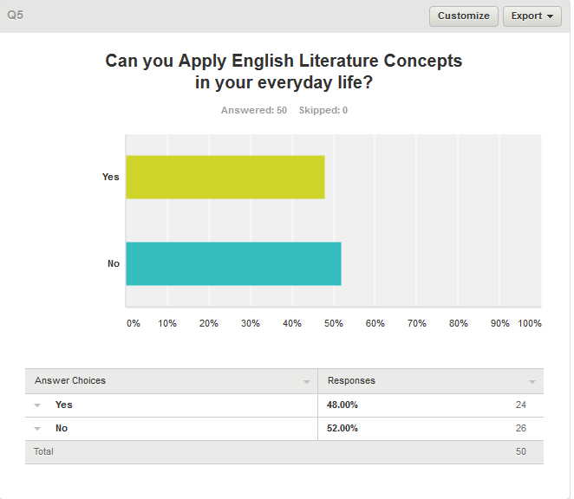

Fig 2.5: Bar graph showing the levels of cognition within respondents.

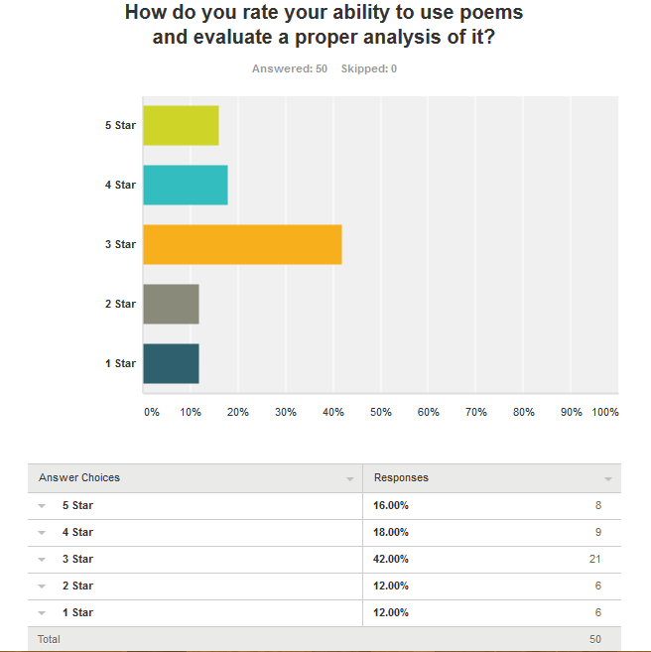

Fig 2.6: Bar graph showing the impressions of respondents about analysis.

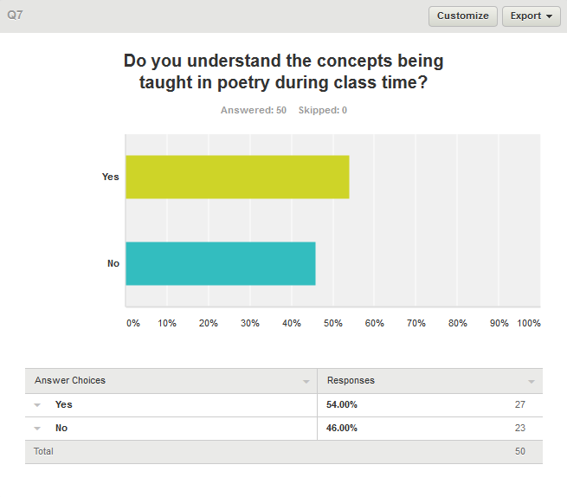

Fig 2.7: Bar graph representing the level of understanding gained in the classroom.

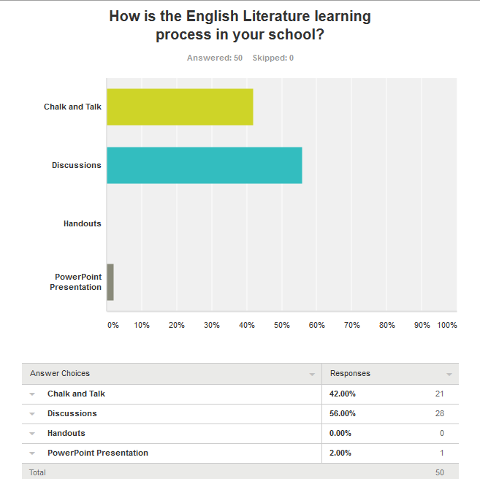

Fig 8: Bar graph showing methods of teaching in school

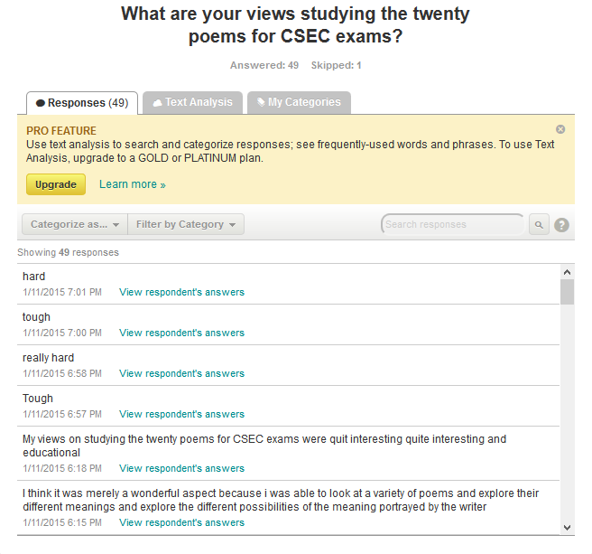

Fig 9: Menu Showing open-ended responses.

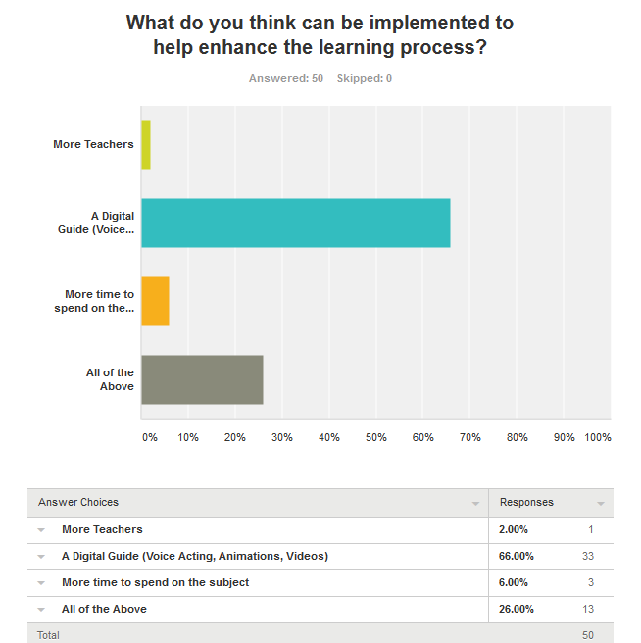

## **RATIONALE**

The English Literature Interactive Journal seeks to aid students and teachers to grasp the main idea and true meaning behind English B at the CSEC Level. Based on the data collected, the researchers discovered that respondents (students) have a serious problem with analysing poetry for CSEC examinations. Students displayed a noticeable problem with applying the English Literature concepts they learned into the real world. The English Literature Interactive Journal hopes to resolve these difficulties faced by these students by integrating digital tools such as videos, sounds and animations, displaying them in a user-friendly and interactive display. The Literature Journal brings knowledge to noticeably less-developed areas from which students cannot access quality education (this is inclusive of extra lessons).

Despite the benefits to the target audience, the implementation of the Interactive Journal may have a negative effect on student attendance to classes and school in general due to the perception that the Interactive Journal as well as the Critical Thinking Tools will replace the teacher and thus making it no fuss to attend school. It is emphasized that students do not see this journal a replacement for classes but rather an aid for the classroom. The Interactive Journal should be used in combination to the traditional learning experience in the classroom to integrate literature from ***both vantage points***.

## **PITCH**

The traditional way of presenting a sales pitch is done to a live audience (which includes investors) and your target market. This project is not a Traditional Project. It’s a progressive educational tool using modern technology to communicate educational content and foster greater self-learning and cognitive development. With the previously stately rationale as support, it seemed fitting to denounce the idea of a traditional pitch for our product.

The pitch for this project will be done online, hosted on a popular video hosting service – YouTube. This idea was echoed by the numerous amount of students who are now online thanks to ICT development and are actively searching for alternative tools for English B learning rather than sitting in a (seemingly) boring classroom [as seen in the data collected]. This means that YouTube viewers – arguably the recipients of the world’s biggest video site are our target market; more specifically a subset for the Caribbean region and by posting the pitch online, speaking directly to students who are looking for alternative learning methods we are able to foster awareness and product recognition, it also serves as a natural marketing benefit since hosting is done free. When students view the pitch online a link will be provided to access the demo edition of the Interactive Journal.

We see investors as an integral part of our sales pitch. Using an online pitch; the researchers will be able to take advantage of Crowdfunding. Crowdfunding is the practice of funding a project or venture by raising monetary contributions from a large number of people, today often put in use via [internet](https://en.wikipedia.org/wiki/Internet)-mediated registries. The crowdfunding mechanism can allow not only business investors to contribute funds but regular viewers such as students and teachers as well. This Crowdfunding element will be hosted via the popular site Indiegogo. Indiegogo is an international [crowdfunding](https://en.wikipedia.org/wiki/Crowdfunding) website founded in 2008 by Danae Ringelmann. Indiegogo allows people to solicit funds for an idea, charity, or start-up business. Indiegogo charges a 5% fee on contributions. This charge is in addition to credit card and [PayPal](https://en.wikipedia.org/wiki/PayPal) charges that range from 3.5% to 9%. The Indiegogo link will be posted in the YouTube video for potential investors.

To Access the Pitch:

<https://www.youtube.com/channel/UCFq1YQSR6LOUG8Vc1rQIgoA/videos?sort=dd&view=0&shelf_id=0>

Backup in the event of error: <https://drive.google.com/folderview?id=0B3HgklS7JCwpMXM1amV2NDh3Y2s&usp=sharing>

***PROPOSAL***

## **PROJECT OVERVIEW**

The product will essentially, be a digital guide that contains text, animation, music, voice acting and graphics. The Interactive Literature Journal will include various digital content that will aid students’ cognitive ability to interpret and analyse and apply poetry in real life situations or in secondary examinations (CSEC). These digital tools include:

* A written body of the poem which the viewer selects. This is inclusive of a pictorial representation of the premise of the poem.
* An aural representation of the poem that the viewer selects, this audio file will demonstrate the proper recital of the poem as the writer intended, and will be accompanied by an equaliser.
* Summary of the poem - This section of the Literature Journal will contain an in-depth analysis of the poem including key points, special words and phrases and the theme the poet presents.
* The final part of the Literature Journal will feature 3 videos titled: Mood and Tone, Literary Devices and Real Life Application. These videos include animations as well as static graphics to help students analyse and interpret poetry at an acceptable level.
* The Literature Journal will be sold for USD 9.99 per copy and available through Adobe Creative Cloud Upload Centre, for the initial 3 months a demo edition will be of a free download to anyone on through a web link. This will be done to promote awareness, receive feedback and gain potential investors.

## **CONCEPT (DRAFT DESIGNS)**

***Header***

This will enable users to understand the poem that is being focused on, the example of the wireframe is present below followed by an actual example.

  
Fig 13 Wireframe showing the ‘HEADER’ of the product

E.g.

.

***Introduction***

This segment of the Literature Journal users will be able to get a brief Introduction of the poem, it will include the transitory background about the Poet, where he wrote this poem and why he wrote it.



Fig 14 Wireframe showing ‘Introduction of poem’

E.g.

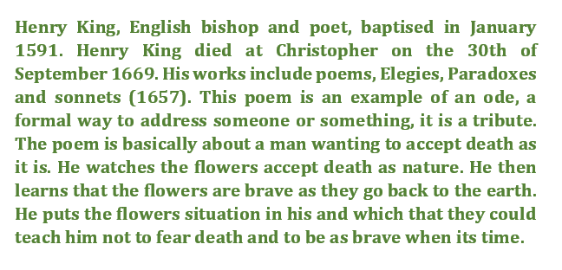

***Body of poem***

This aspect of the Literature Journal will encase the stanzas of the actual poem and will include a picture of the poet in the surroundings he was when writing the poem.

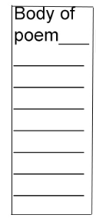

Fig 17: Wireframe showing the ‘Body of poem’

E.g.

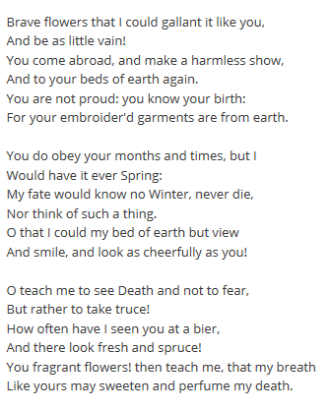

Fig 18: Picture showcasing the stanzas on ‘A Contemplation upon Flowers by: Henry King’

***Audio of Poem***

This sector of the Literature Journal will enable users to hear aurally the poem that he/she is studying. The Audio will be accompanied by an equaliser while the poem is being played.



Fig 19: Wireframe showing the sound icon that will be displayed in the Literature Journal

***Summary of Poem***

This Section of the Literature Journal will contain an in-depth analysis of the poem including key points, special words and phrases and the theme the poet presents.

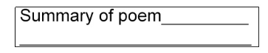

Fig 21: Wireframe showing the Summary of the Poem

E.g.

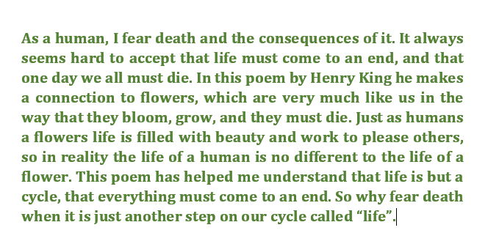

***Videos on Mood and Tone, Literary Devices, Real Life Application***

The videos (3) will contain Interactive Discussions featuring Animations, Slides, Questions and Sound. As the viewer’s listens to the person who is explaining the Mood and Tone, Literary Devices and the Real Life Application animations would show the exact message the poet want to portray, this will enable students to conceptualize the idea.



Fig 23: Wireframe showing the Videos that will enable students to understand the concept

**Proposed Draft Designs for the Interactive Videos, a major component in the Interactive Journal.**

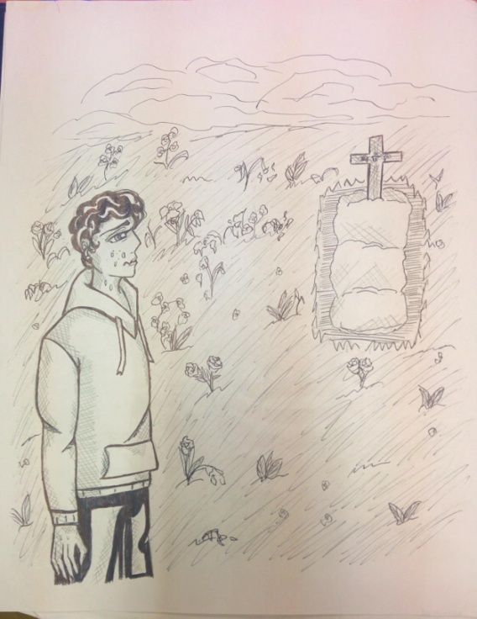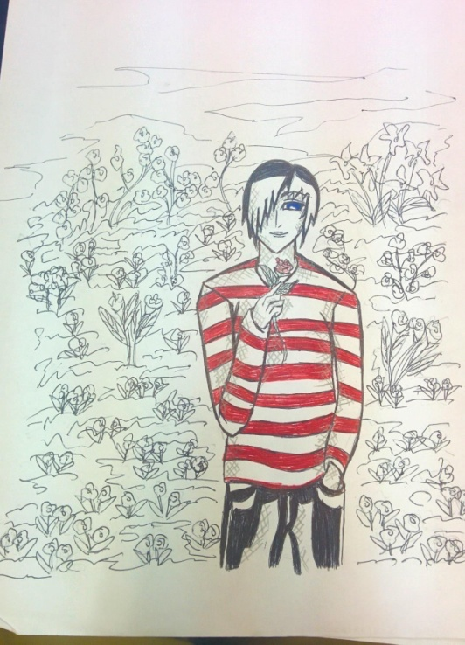

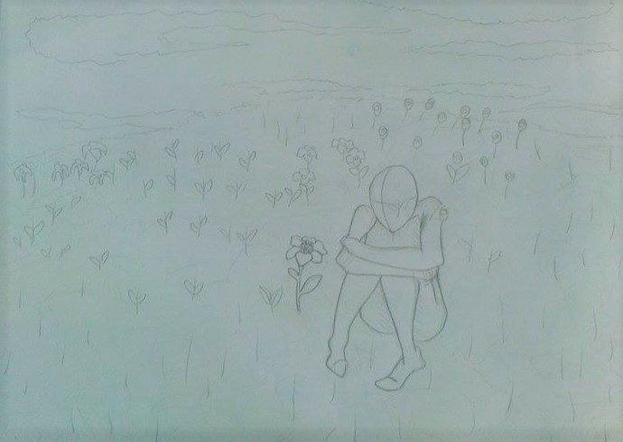

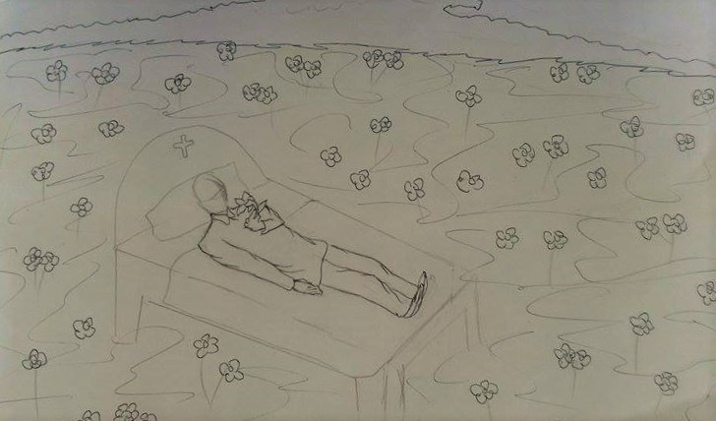

## **METHODOLOGY, TOOLS, TECHNIQUES**

The development of the product involves 3 main resources – hardware, software and humans. The researchers utilized questionnaires to test and prove that the problem identified from observations was truly existent, and in doing so; the researchers utilized the fourth stage of the creative process – ideation. A solution was chosen and it was implemented in the project, furthermore the researchers went on to evaluate [create, initiate, develop] the Literature Journal, thus utilizing the full process of creativity. In the creation of the Literature Journal various hardware and software tools were used to help in the successful creation of the Literature Journal. These tools are:

* **Google Docs** – played an integral part in the development of this project, by allowing researchers to edit and process this School Based Assessment.
* **Microsoft Office PowerPoint 2013 (Office Timeline)**– was used to produce the Milestone Chart as well as the Timeline of Events.
* **Microsoft Office Excel 2013 -** This was used to create and design the Gantt   
   Chart/Production Chart.
* **Survey Monkey** – was used to create the data capture instrument (questionnaire).
* **Adobe Photoshop Creative Cloud (CC) 2014** – aided researchers in editing graphics, cropping pictures, designing the wireframe, and creating logos.
* **Adobe Audition Creative Cloud (CC) 2014** – was used to mix and cut audio from the voice recital of the poem as well as sound from the animatic.
* **Adobe After Effects CS6 2014 –** was used to create visual effects, motion graphics, and compositing applications and was also used in the post-production process of the interactive videos. It was also used for keying, tracking, rotoscoping, compositing, animation of the animatic and other motion graphics in the Interactive Journal.
* **Adobe Premiere Pro CS6 2014 –** was used to edit and render the interactive videos.
* **Adobe InDesign CC 2015 –** was used to create the interactive journal as it provides a wide variety of features such as digital publishing, web publishing, e-books and yours truly Interactive PDFs.
* **Google Keep –** was frequently used to draw the storyboard frames.
* **Google Drive –** was used to store project components such as videos, ideas, drafts, completed areas etc. The information was shareable to all group members in the project so it can be accessible to them at any moment.
* **Adobe Acrobat Pro –** was used to view and access the interactive Journal after its completion as well as converting the SBA to PDF.

## **BUDGET**

|  |  |  |  |
| --- | --- | --- | --- |
| Income | | Expenditure | |
| Item | **Amount  $** | **Item** | **Amount  $** |
| Angel Funding | $10,000 | Adobe Stocks(CC for Teachers and Students) | 12,000 ( 3 months) |
| Capital Injected | $35,000 | Utilities, Story Board Sheets | 5,500 |
|  |  | Transportation Fee | 900 |
|  |  | Pitch Expenses (Purchase of Tripod and Portable Mics) | 10,000 |
|  |  | Payment Fee (Voice Actors) | 4000 |
|  |  | Rental of Equipment ( 2nd Camera & Tripod, Rental of Chairs and Services by NCERD) | 12,500 |
| Total | 45000 | **Total** | 45000 |

$$ROI=\frac{Gain from Investment-Cost of Investment}{Cost of Investment}$$

Cost of Investment = $35000

Gain from Investment:

Given that the price of the product = $2000 GYD or 9.99USD therefore, if 100 copies of the product are sold = 100*$2000GYD = $200’000 GYD or USD $1000.

$$ROI=471\%$$

**The Return on Investment for every 100 sold products would be 471% higher than original investment.**

$$ROI=\frac{\$200'000-\$35000}{\$35000}$$

$$ROI=\frac{33}{7}*100$$

# ***PART 2: PROGRESS AND PROCESS***

## **TIMELINE**

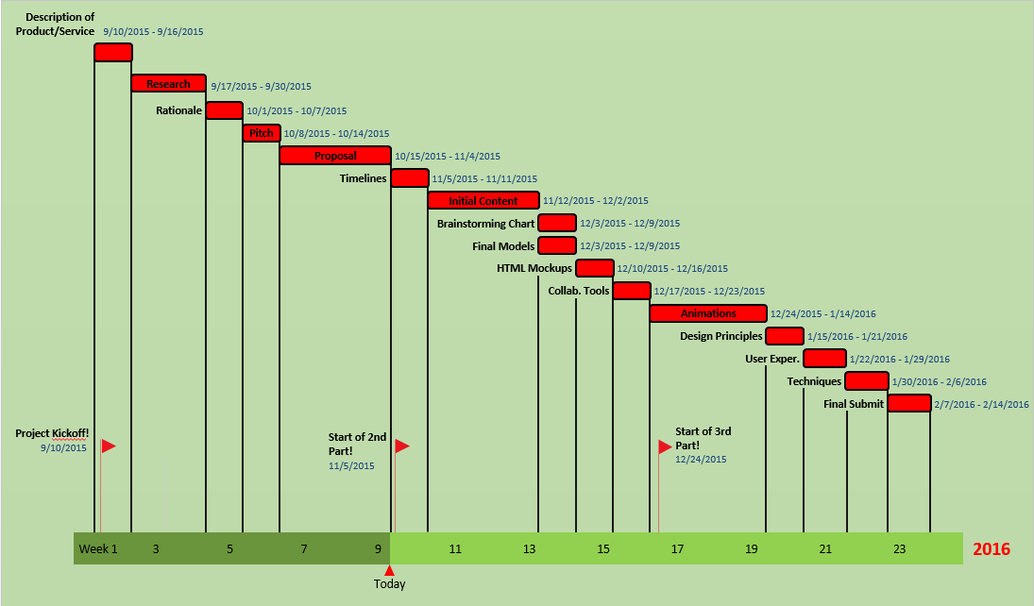

## **MILESTONE CHART**

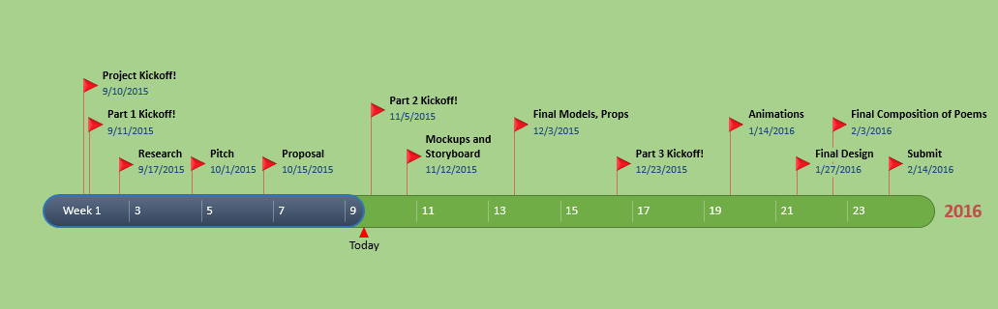



## **PRODUCTION SCHEDULE**

*INITIAL CONTENT/SCRIPTS/MOCK-UPS/ROUGH DESIGNS*

## **SCRIPTS FOR STORYBOARD**

***Page 1: Shot 1***

Teacher: *“Good morning class. Welcome to literature Class, I’ll pass this paper around so you guys can copy your books. You’ll need these books to study from and follow in class”*

Student 1: *“Oh, great…more books.”*

Student 2: *“Yes. With these books, I can get a head-start on the term.”*

Student 3: *“Great, I’ll just cram the content for the exam”*

***Page 1: Shot 2***

Son: *“Hey Ma, the teacher gave us this list of books.”*

Mother: *“Son, I’ve already explain to you the situation”*

Mother: *“You know we can’t afford these books since your father left us.”*

Son: *“Yea, it’s okay Ma, I understand……*

***Page 1: Shot 3***

Teacher: *“Okay kids, this is your first test of the term and it’ll be based on section 6 – 9 at your English text you were supposed to purchase.”*

Student 2: *“Hehe, I studied all of this. I will pass, I must pass.”*

Student 3: *“Meh, I really don’t care, this subject is boring”*

Student 1: *“Oh no, I’ll fail…without that book I’m practically nothing.”*

***Page 2: Shot 1***

Student 2: *“Hi guys. How do you think you did on the exam?”*

Student 1: *“That test was hard man. The stuff looked like Latin to me.”*

Student 3: *“It was okay, I guess. Didn’t really care”*

Student 2: *“C’mon fellas, it wasn’t that hard.”*

Student 1: *“Heh, easy for you to say. You had the book, Miss fancy pants.”*

***Page 2: Shot 2***

Student 1: *“I know I would’ve failed…*sobs*…everything I needed to pass was in those books…*sob*.*

***Page 2: Shot 3***

Developer 1: *“This e-litronl will incorporate everything in the syllabus and more.”*

Teacher: *“Interesting…”*

Developer 2: *“Now, to close out our presentation, we’ll be giving you teachers a free copy of this product to try out yourselves.”*

***Page 3: Shot 1***

Teacher: *“I noticed you failed my test. In fact, you had the worst paper in yourlevel.”*

Student 1: *“…”*

Teacher: *“But don’t feel discouraged, I received this thing called e-litronl or something. I’m a little sceptical about it. So I’m giving you it to try.”*

Student 1: *“Thanks Miss, I really appreciate it.”*

***Page 3: Shot 2***

Student 1: *"Ms. really thinks some product is going to help me? She’s mistaken"*

*\*looks doubtful at product\**

*"But... i guess trying won't hurt"*

*\*loads e-litronl\**

*"Wow!!! is this fuh real? there's some really incisive content here, i must pass my final exam, i will pass my final exam"*

***Page 3: Shot 3***

Teacher: *"Okay class, this is your final exam of the term and, it's worth 50%, do your best"*

Student 1: *"heh, this'll be a piece of cake"*

Student 2: *"... another day, another test"*

Student 3: *"what? How am i supposed to know why the writer chose that tone and mood? I’m not physic"*

***Page 4: Shot 1***

Student 1: *"guys, if you thought you did poor on the test, you should try this"*

*\*shows e-litronl to friends\**

Student 2: *"gimmegimme, I’ll plead with Ms to give me another chance"*

Student 3: *"can't hurt to try alternative methods"*

***Page 4: Shot 2***

Student: *"hey Ms, thanks for the e-litronl, it helped a lot"*

Teacher: *"really? I’ll have to try it myself"*

Student 1: *"do you know if it's for other subjects?"*

Teacher: *"you know what? That’s a really good idea"*

***Page 4: Shot 3***

Developer 1: *“comrades, we were able to provide much needed help to English literature students"*

Developer 2: *"i agree, we should do more"*

Developer 1: *"i propose we diversify our critical thinking tool across all fields"*

## **MOCK-UPS**

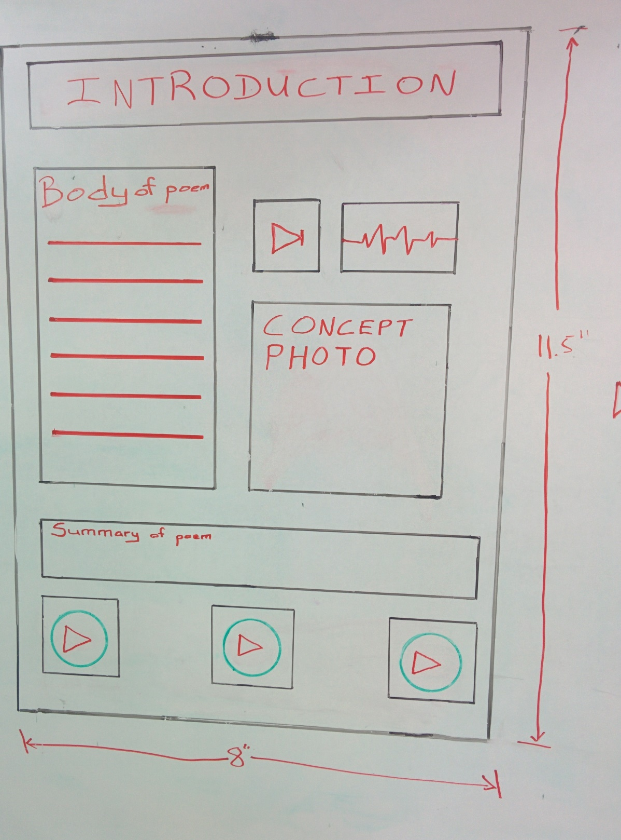

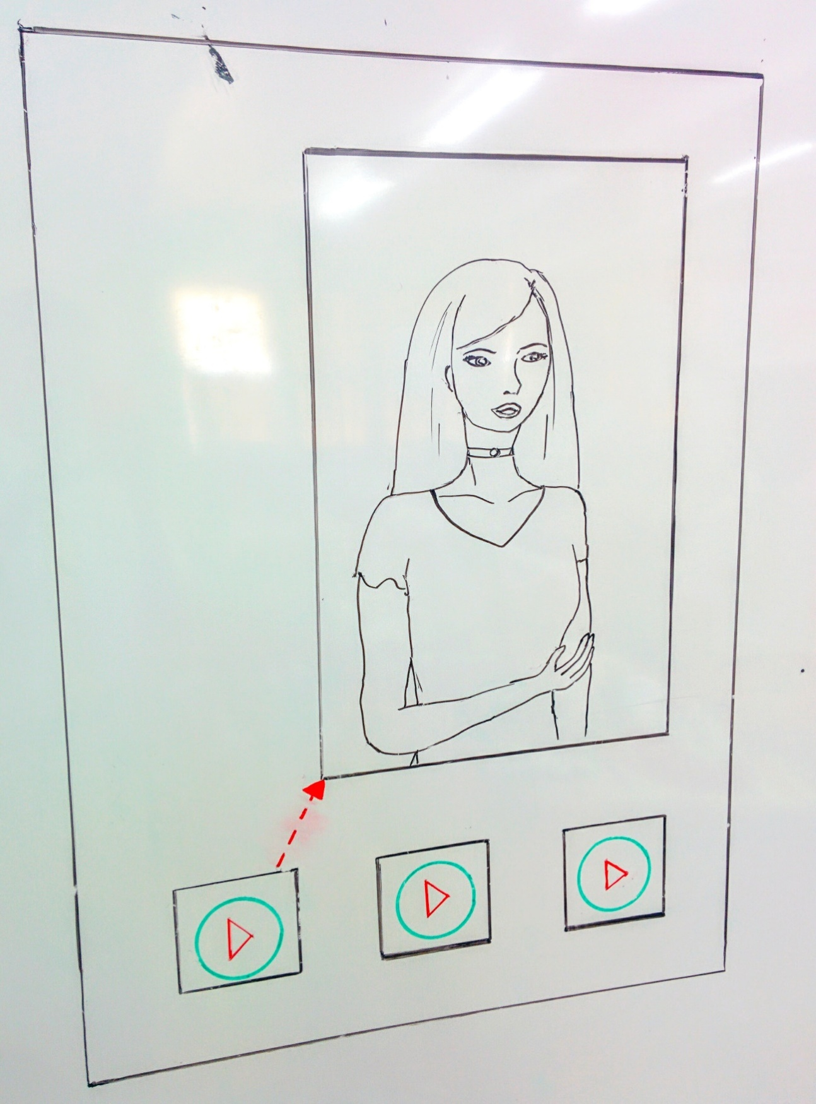

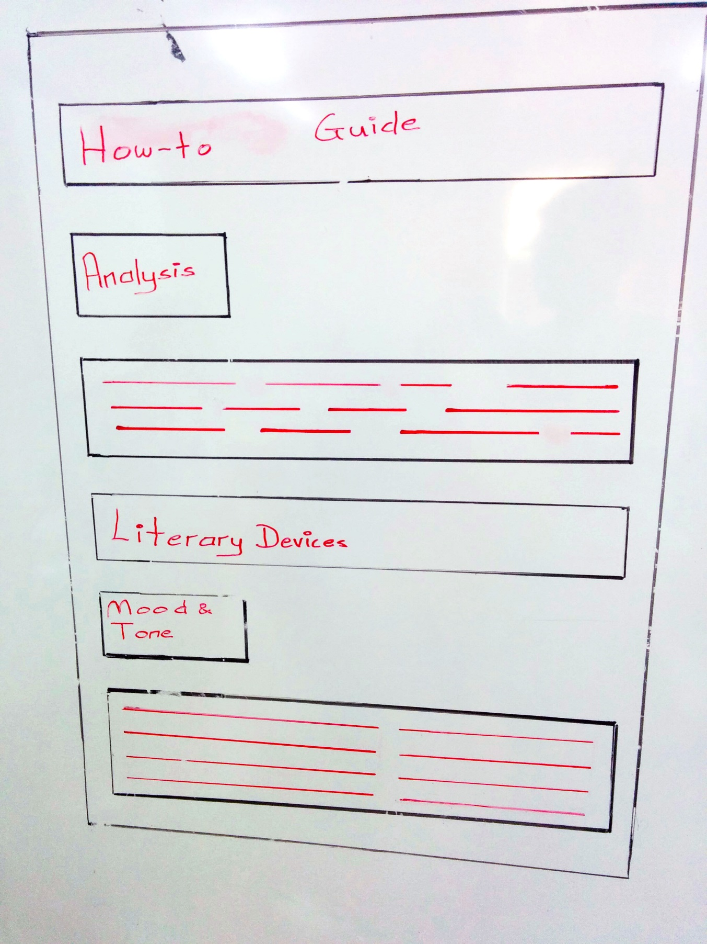

*PREPRODUCTION*

*/REVISUALISATION/*

*INTERFACE DESIGN*

## **NAMING THE PROPOSED PRODUCT**

ENGLISH LITERATURE JOURNAL

**E - Litronl**

RONLL

E

LIT

## **STORYBOARD CONCEPT**

In conceptualizing the storyboard, the researchers derived a production script which showed dialogue between characters. This is seen above in the Initial Content/Script/Rough Design/Mock-ups section. The reason behind this was to describe not only the solution but also the problem being solved.

The Storyboard – entitled “A New Hope” speaks about a young lad currently in high school, going through financial struggles and is unable to purchase textbooks and other resources. The dilemma in this young boy life continues to worsen as he fails a test and has the worse grade in the class. Meanwhile his teacher is given an English B Interactive Journal named  
“E-litronl” by education developers. This Prompts the Teacher to give a copy of the “E-litronl” the failing student. Using the journal, the student begins to understand and develop his English Literature Skills be it in the application of literature in real life, literary devices or understanding mood and tone.

## **BASIC STORYBOARD**

Page 1: Shot 1

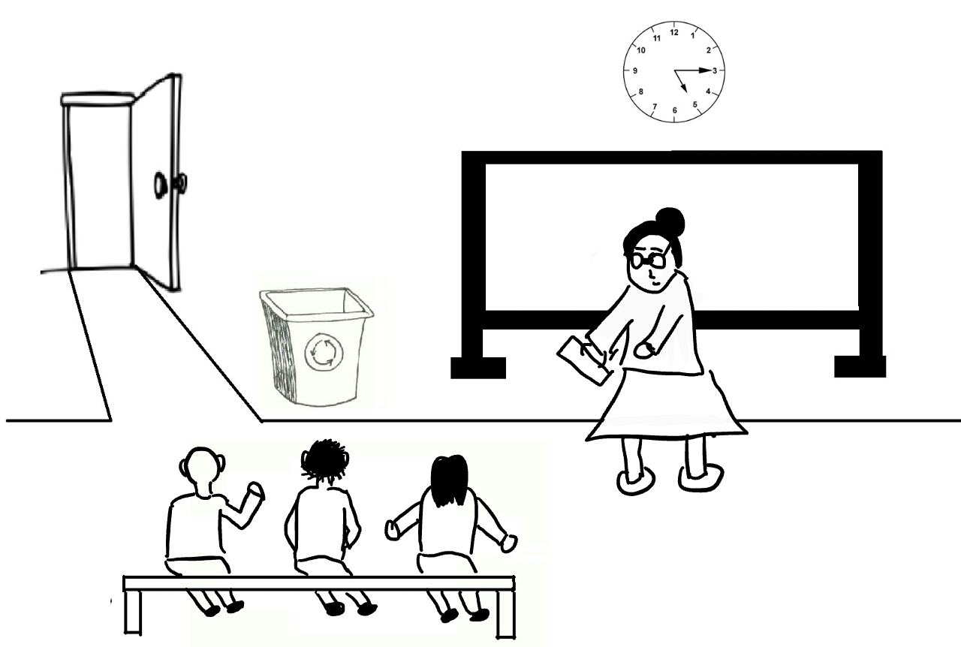

Action:

Teacher: Handing paper to students, talking to students.

Student 1: Complaining.

Student 2&3: Talking.

Dialogue:

Teacher: “Good morning class. Welcome to literature Class, I’ll pass this paper around so you guys can copy your books. You’ll need these books to study from and follow in class”

Student 1: “Oh, great…more books.”

Student 2: “Yes. With these books, I can get a head-start on the term.”

Student 3: “Great, I’ll just cram the content for the exam”

Page 1: Shot 2

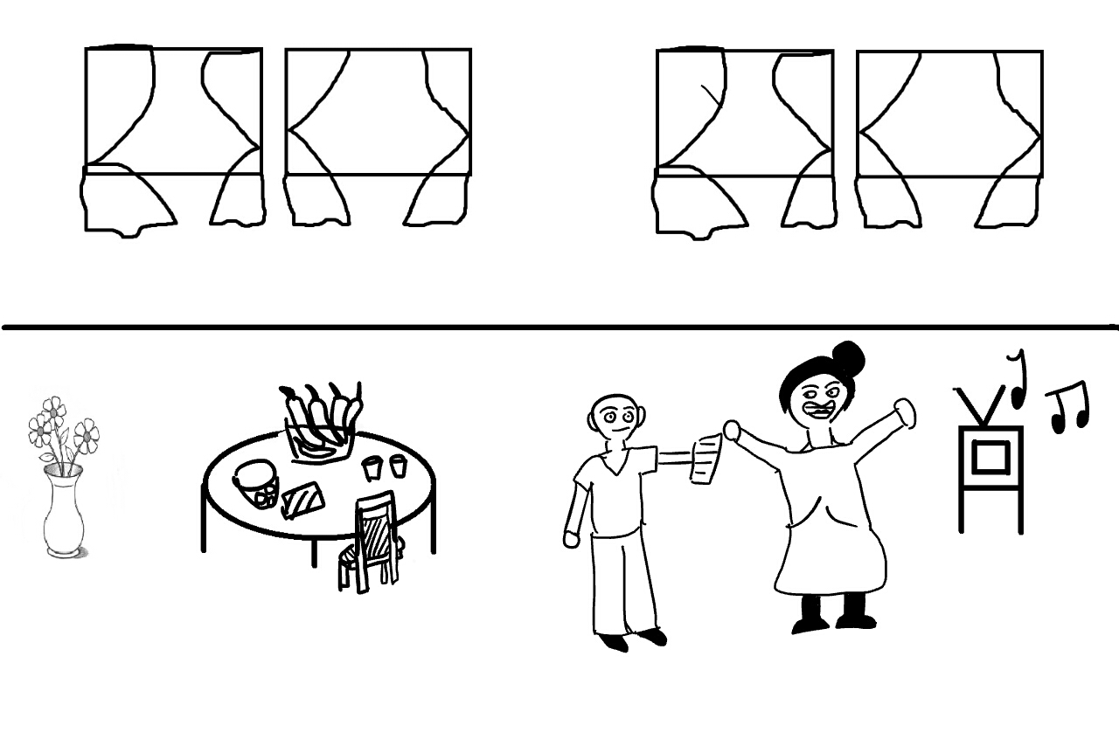

Action:

Student 1: Handing list to mother, talking.

Mother: Talking.

Dialogue:

Student 1: “Hey Ma, the teacher gave us this list of books.”

Mother: “Son, I’ve already explain to you the situation”

Mother: “You know we can’t afford these books since your father left us.”

Student 1: “Yea, its okay Ma, I understand……

Page 1: Shot 3

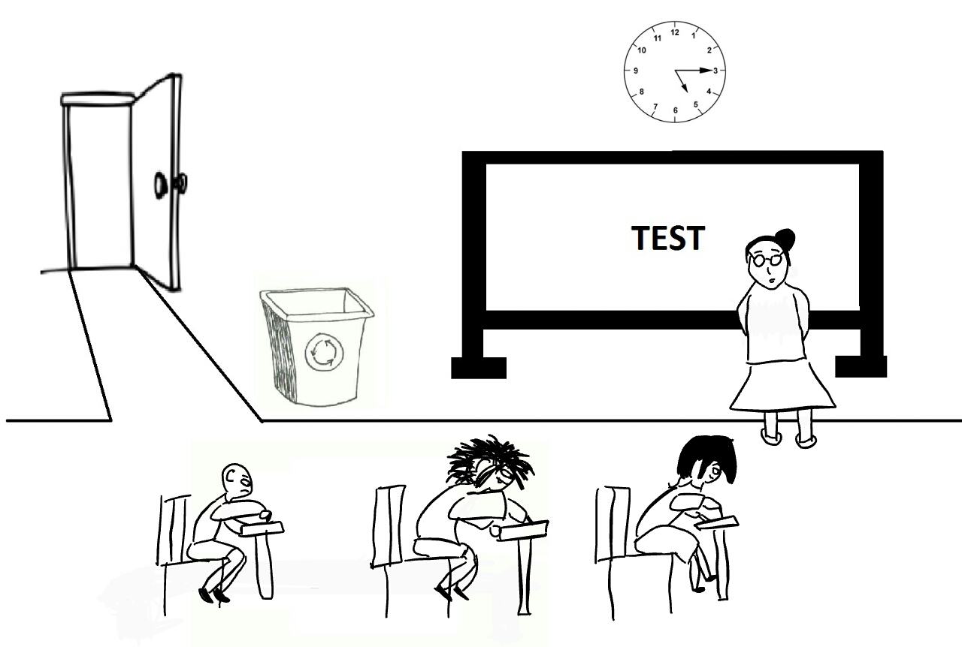

Action:

Teacher: Supervising a test.

Student 2&3: Feeling optimistic.

Student 1: Feeling depressed.

Dialogue:

Teacher: “Okay kids, this is your first test of the term and it’ll be based on section 6 – 9 at your English text you were supposed to purchase.”

Student 2: “Hehe, I studied all of this. I will pass, I must pass.”

Student 3: “Meh, I really don’t care, this subject is boring”

Student 1: “Oh no, I’ll fail…without that book I’m practically nothing.”

Page 2: Shot 1

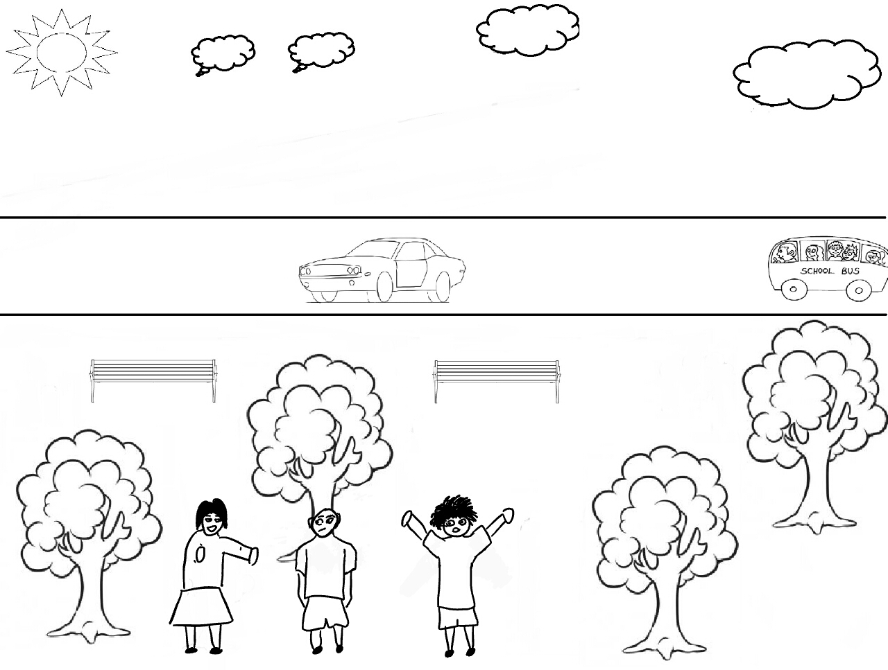

Action:

Student 2: Boasting.

Student 3: Being indifferent.

Student 1: Sulking.

Dialogue:

Student 2: “Hi guys. How do you think you did on the exam?”

Student 1: “That test was hard man. The stuff looked like Latin to me.”

Student 3: “It was okay, I guess. Didn’t really care”

Student 2: “C’mon fellas, it wasn’t that hard.”

Student 1: “Heh, easy for you to say. You had the book, Miss fancy pants.”

Page 2: Shot 2

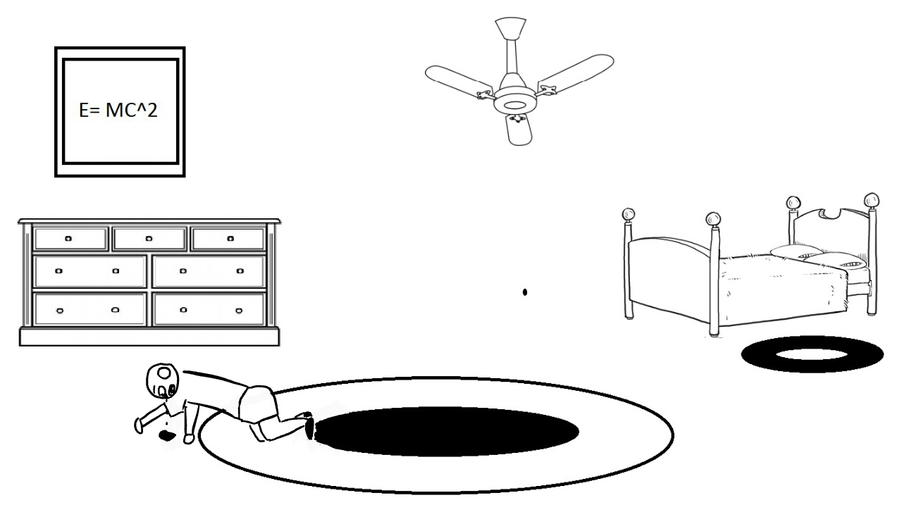

Action:

Student 1: Crying, talking to himself.

Dialogue:

Student 1: “I know I would’ve failed…*sobs*…everything I needed to pass was in those books…*sob*.

Page 2: Shot 3

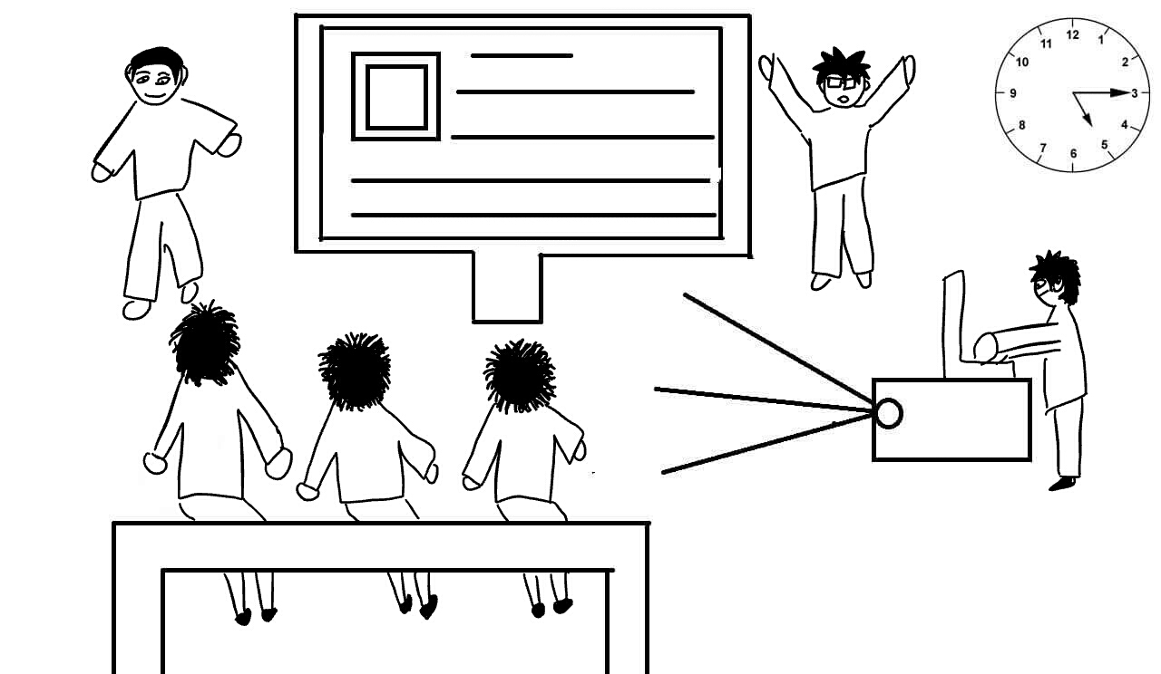

Action:

Developer 1: Giving a presentation.

Developer 2: Hands out a free copy of product.

Developer 3: Handles the projector.

Teacher: Feeling curious about the product.

Dialogue:

Developer 1: “This e-litronl will incorporate everything in the syllabus and more.”

Teacher: “Interesting…”

Developer 2: “Now, to close out our presentation, we’ll be giving you teachers a free copy of this product to try out yourselves.”

Page 3: Shot 1

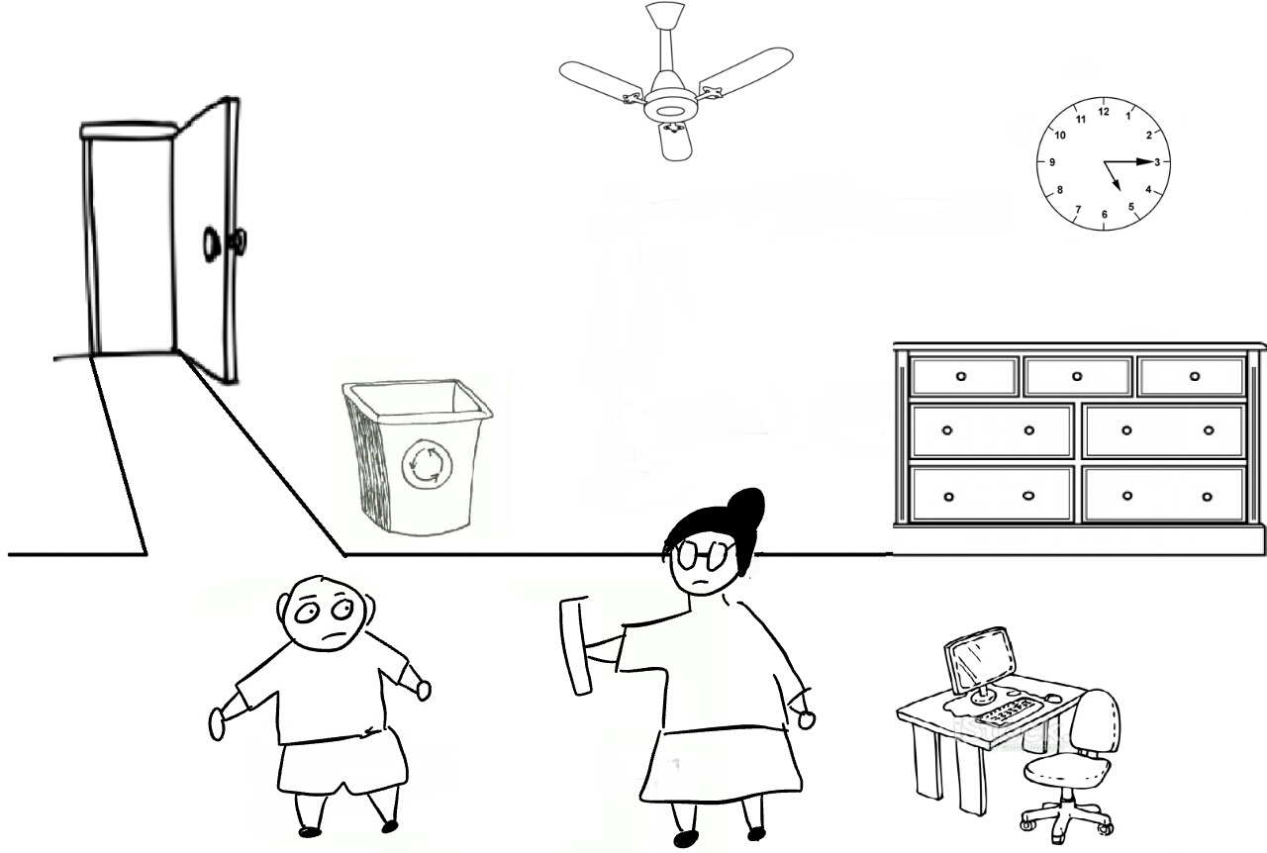

Action:

Teacher: Talking, handing out free copy of product.

Student 1: Talking, takes free copy of product from Teacher.

Dialogue:

Teacher: “I noticed you failed my test. In fact, you had the worst paper in your level.”

Student 1: “…”

Teacher: “But don’t feel discouraged, I received this thing called e-litronl or something. I’m a little sceptical about it. So I’m giving you it to try.”

Student 1: “Thanks Miss, I really appreciate it.”

Page 3: Shot 2

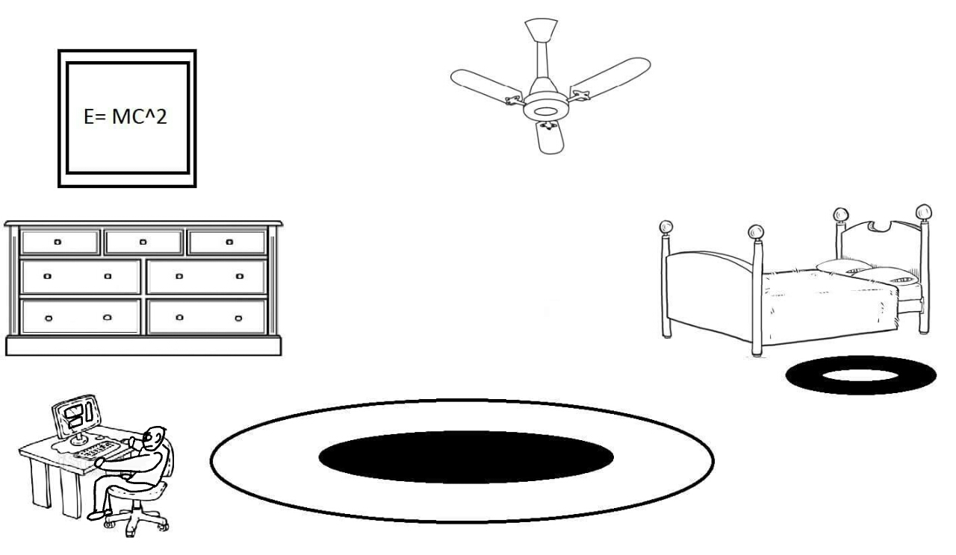

Action:

Student 1: Testing product, talking to himself.

Dialogue:

Student 1: "Ms. really thinks some product is going to help me? She's mistaken.”

(looks doubtful at product)

Student 1: “But... I guess trying won't hurt."

(loads E-litronL)

Student 1: "Wow!!! Is this fuh real? There's some really incisive content here, I must pass my final exam, I will pass my final exam"

Page 3: Shot 3

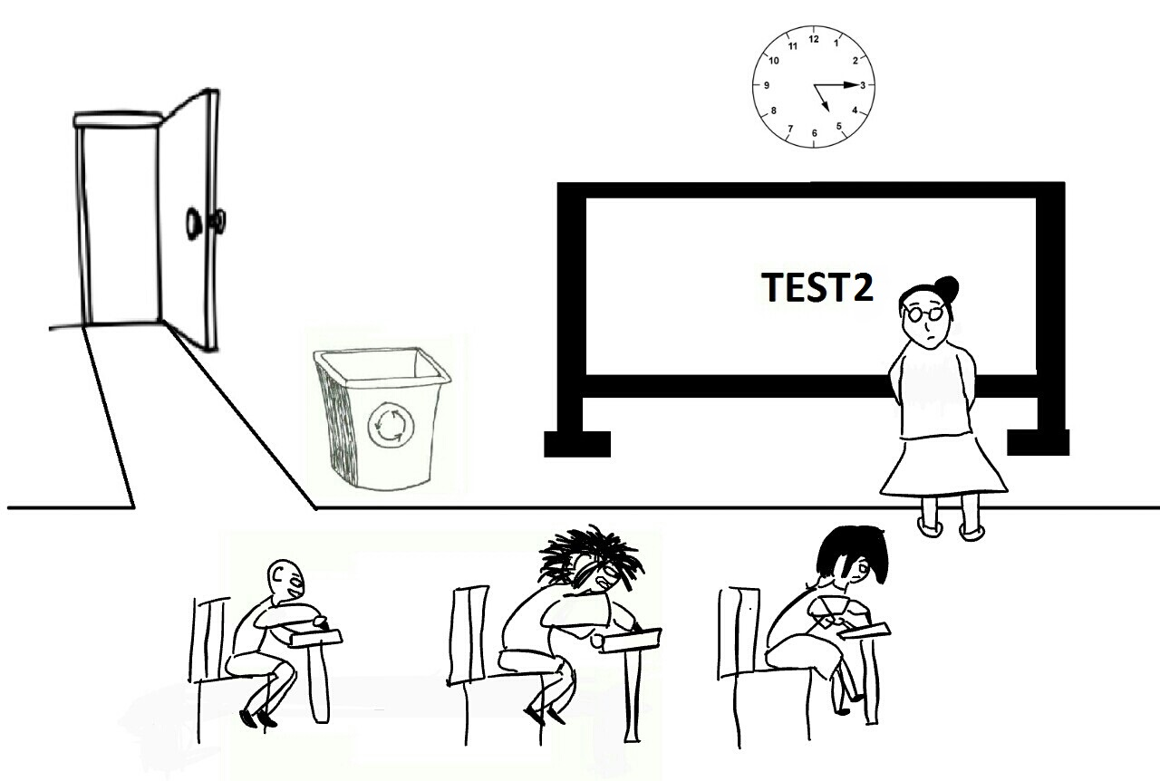

Action:

Teacher: Talking.

Student 1: Feeling optimistic.

Student 2&3: Feeling nervous.

Dialogue:

Teacher: "Okay class, this is your final exam of the term and, it's worth 50%, do your best"

Student 1: "Heh, this'll be a piece of cake"

Student 2: "... Another day, another test"

Student3: "What? How am I supposed to know why the writer chose that tone mood? I'm not psychic."

Page 4: Shot 1

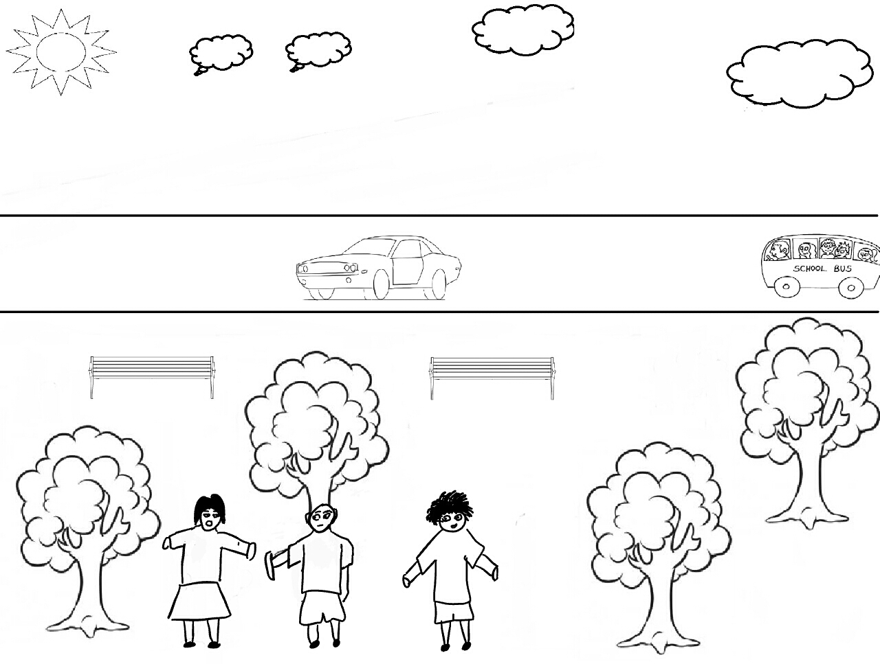

Action:

Student 1: Talking, shows and gives E-LitronL to Student 2 and Student 3.

Student 2&3: Pleading Student 1.

Dialogue:

Student 1: "Guys, if you thought you did poor on the test, you should try this"

(shows E-LitronL to Student 2 & Student 3)

Student 2: "Gimmegimme, I'll plead with Ms. to give me another chance"

Student 3: "Can't hurt to try alternative methods"

Page 4: Shot 2:

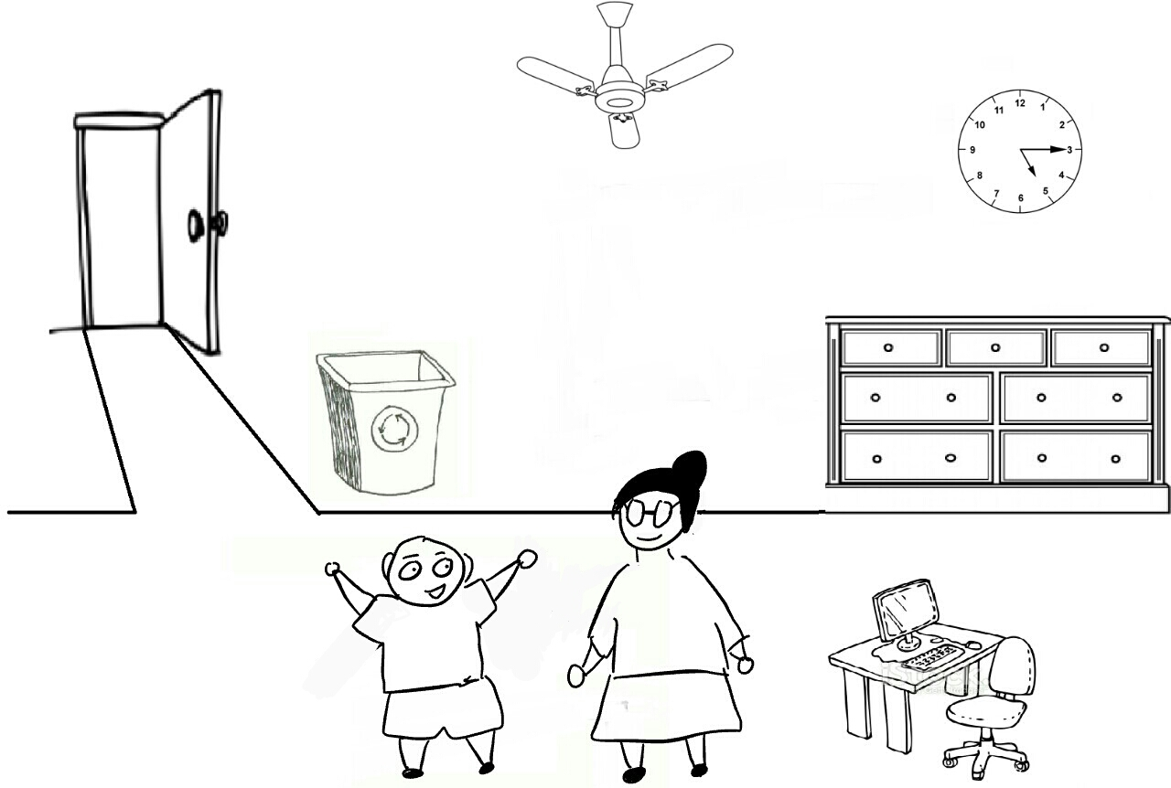

Action:

Student 1: Being grateful, talking.

Teacher: Talking.

Dialogue:

Student 1: "Hey Ms, thanks for the E-LitronL, it helped a lot"

Teacher: "Really? I'll have to try it myself"

Student 1: "Do you know if it's for other subjects?"

Teacher: "You know what? That's a really good idea"

Page 4: Shot3

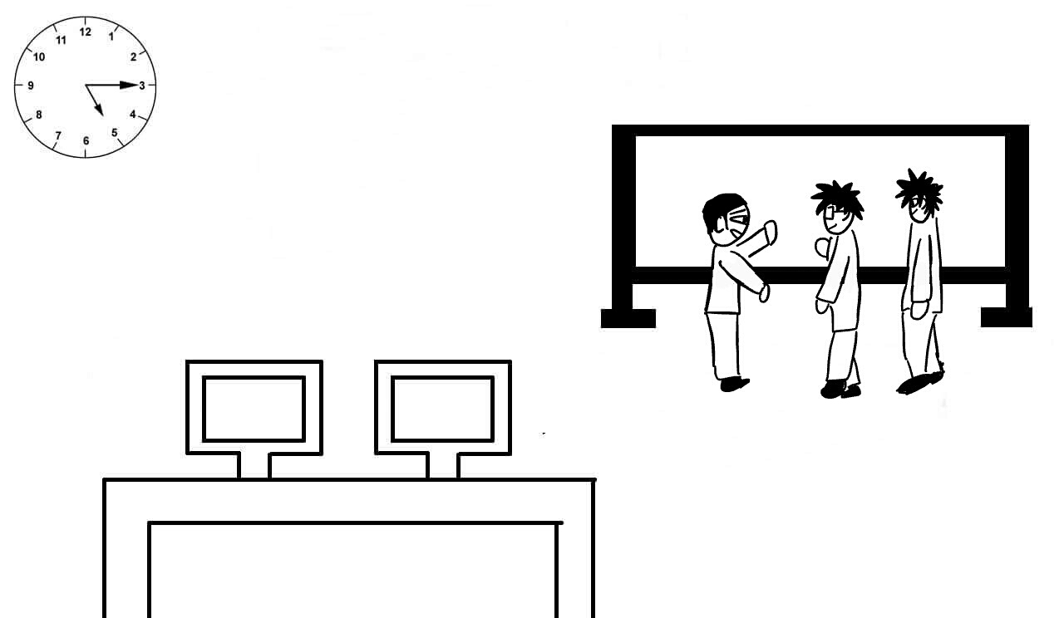

Action:

Developers 1,2&3: Brainstorming new ideas for their product.

Dialogue:

Developer 1: “Comrades, we were able to provide much needed help to English Literature Students."

Developer 2: "I agree, we should do more."

Developer 1: "I propose we diversify our **CriticalThinkingTool** across all fields."

**WIREFRAMES**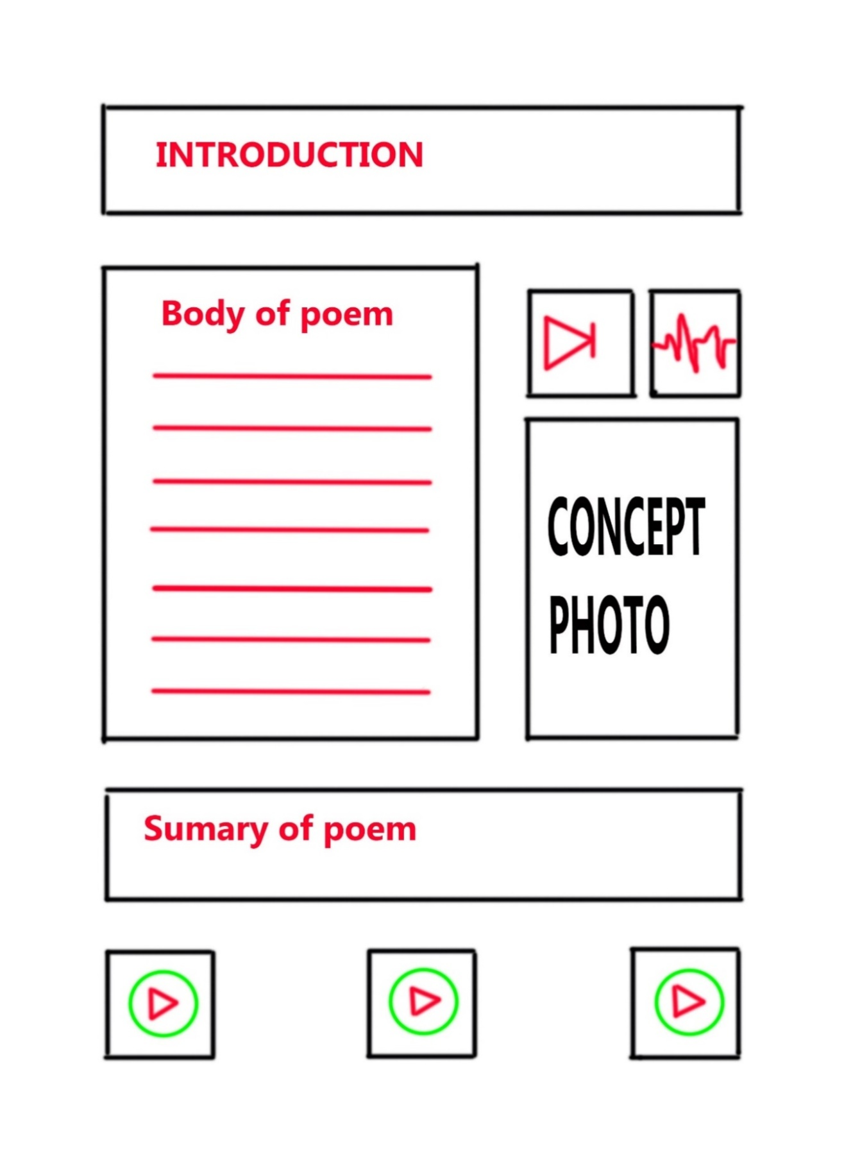

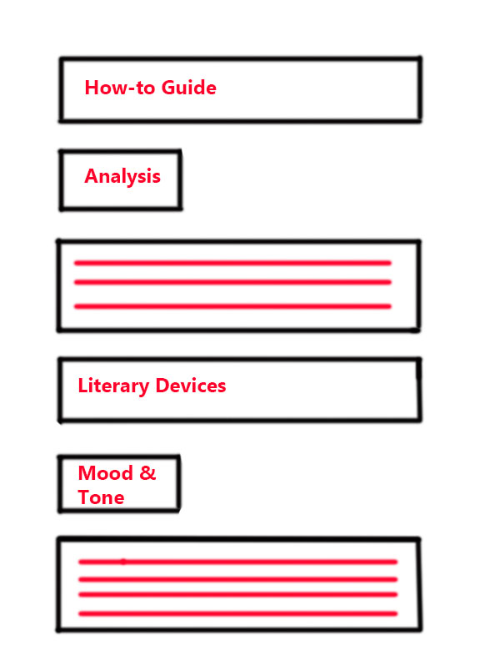

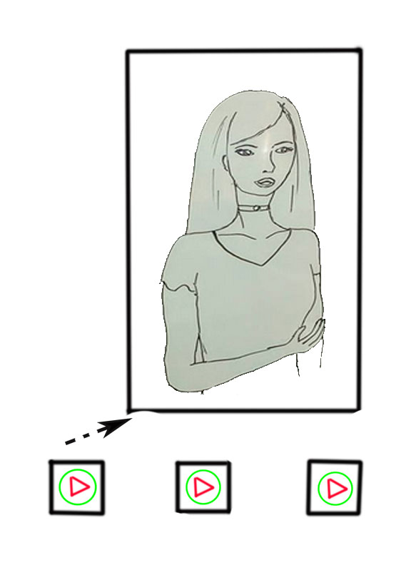

## **PRODUCTION OF WIREFRAMES**

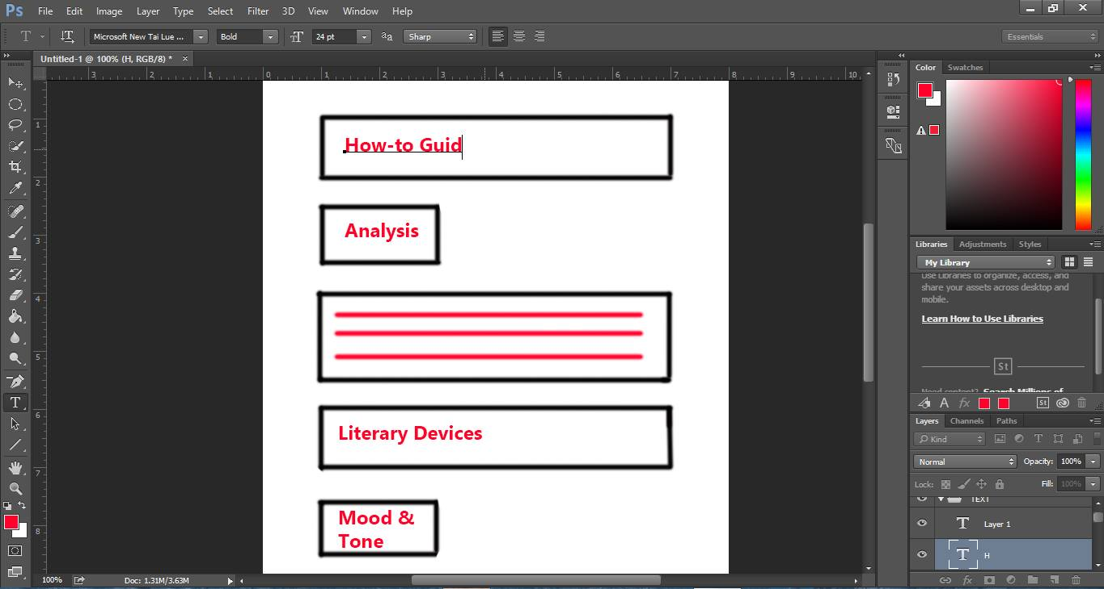

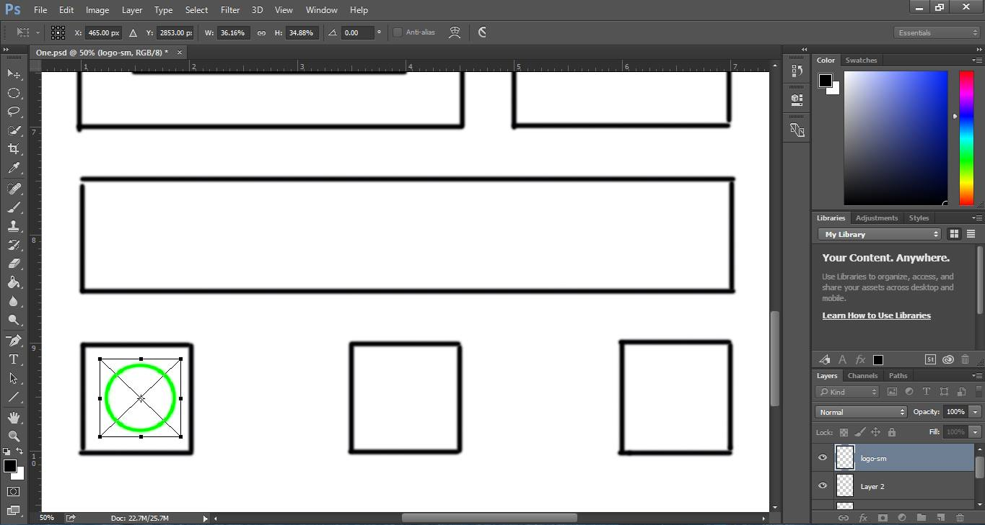

## **ANIMATIC**

**Characters**





Sonny Kothapally (one of the authors of this SBA) played a character in the animatic known as “Student 1’ the main protagonist of the animatic who was the sad and worried student.

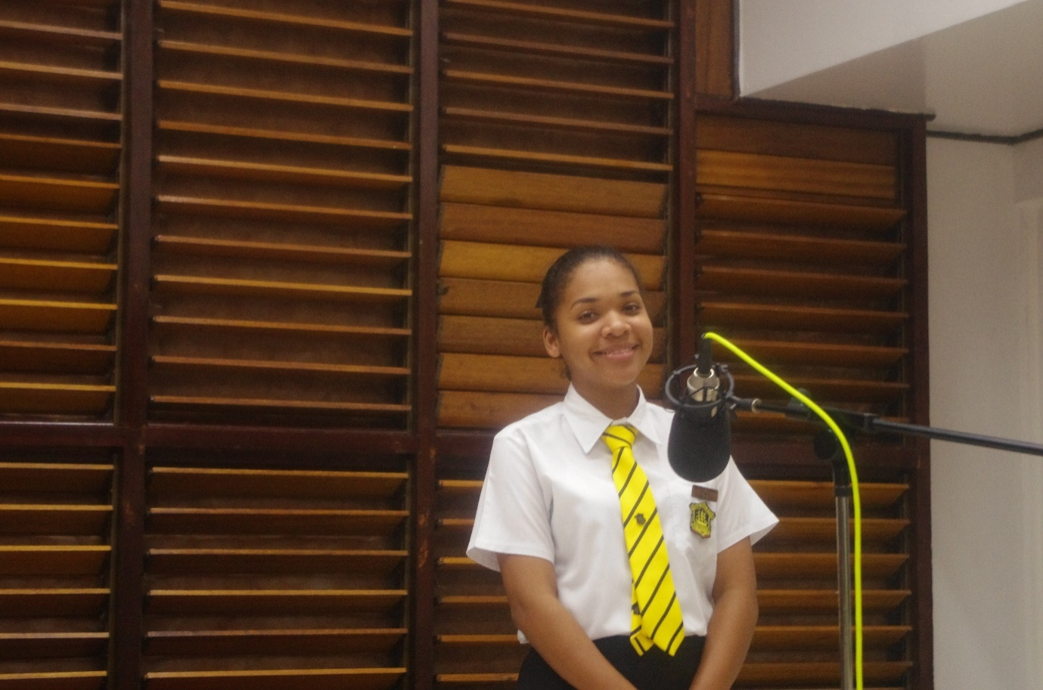

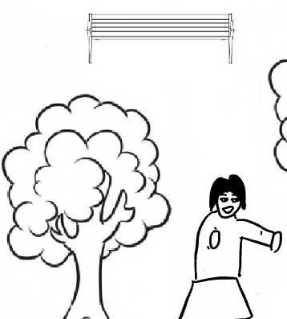

Felicia Collins a classmate and colleagues of the researcher played Student 2 who was the optimistic and positive character.

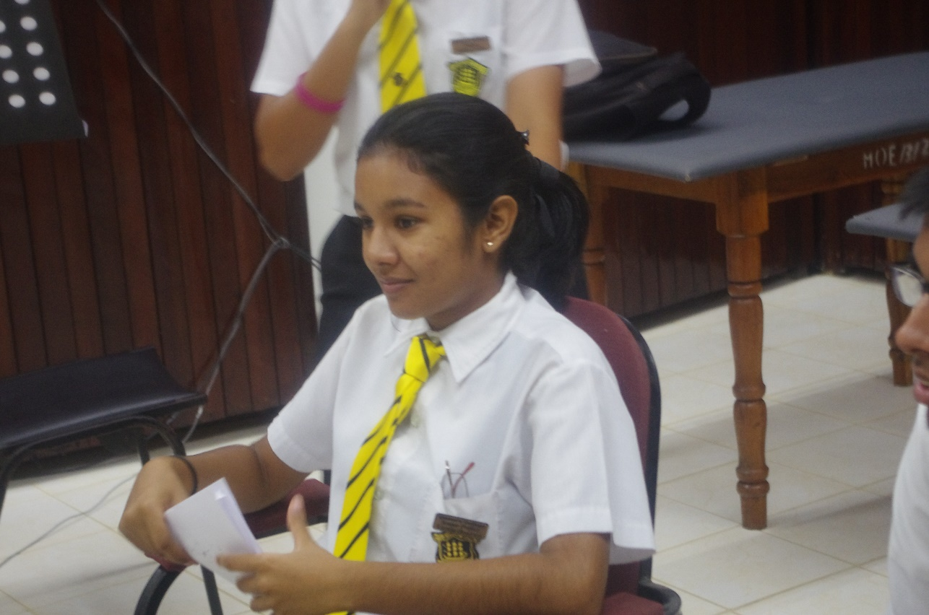

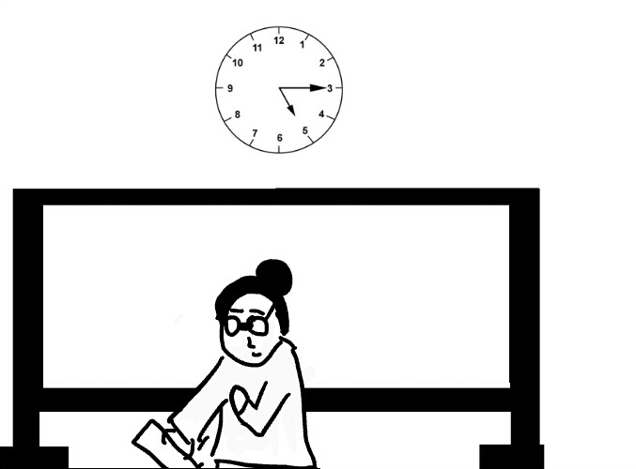



The Character of the Mother and the Teacher were both played by Varsha Boodram, a classmate and colleagues of the researchers.

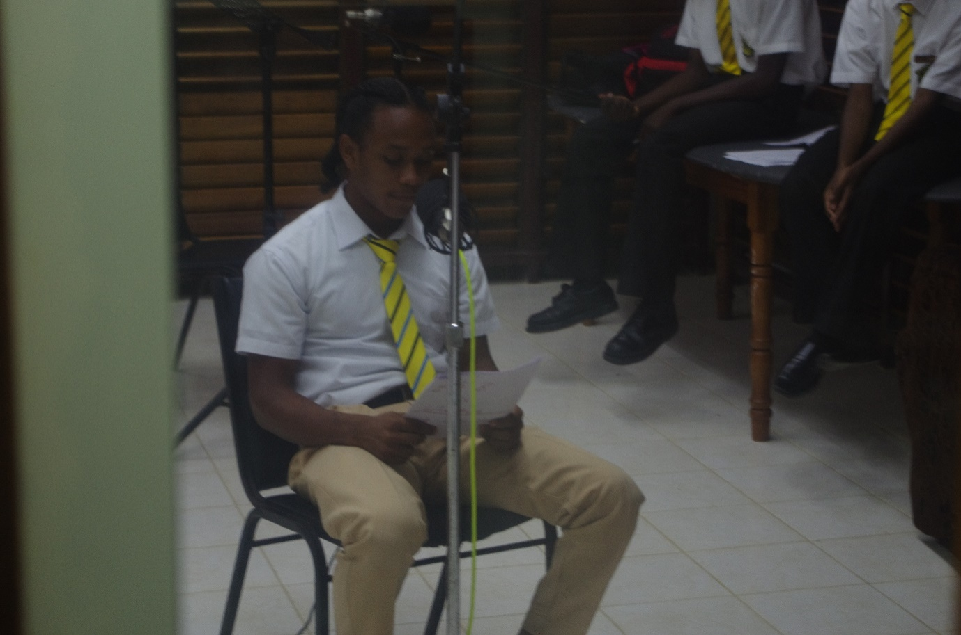



Levi Langellier, a long-time colleague of the researchers played Student 3 who was the boring, uninterested character.

***Recording of the Animatic***

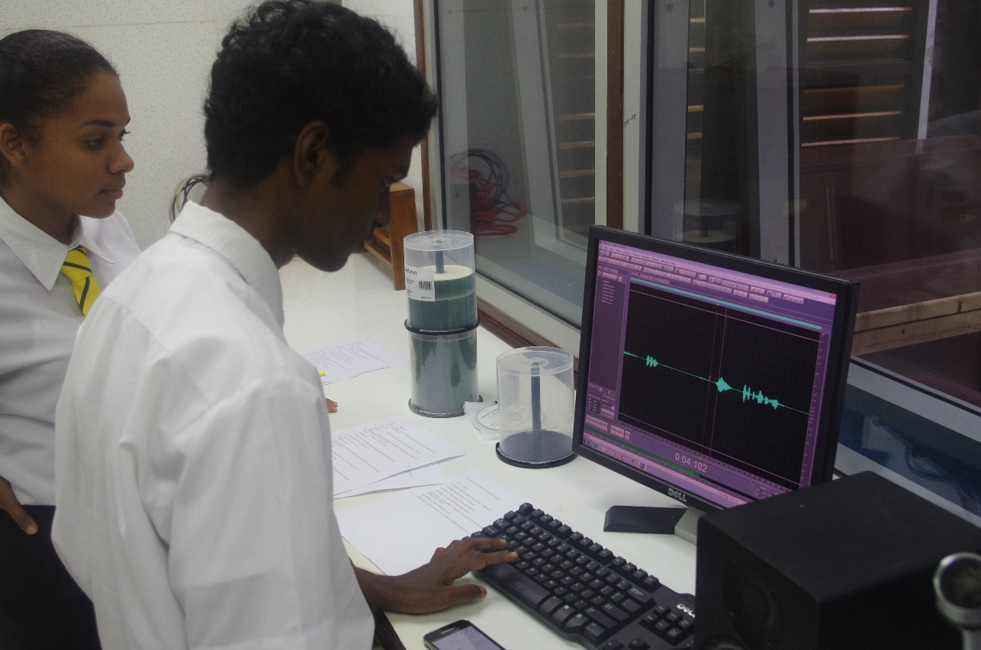

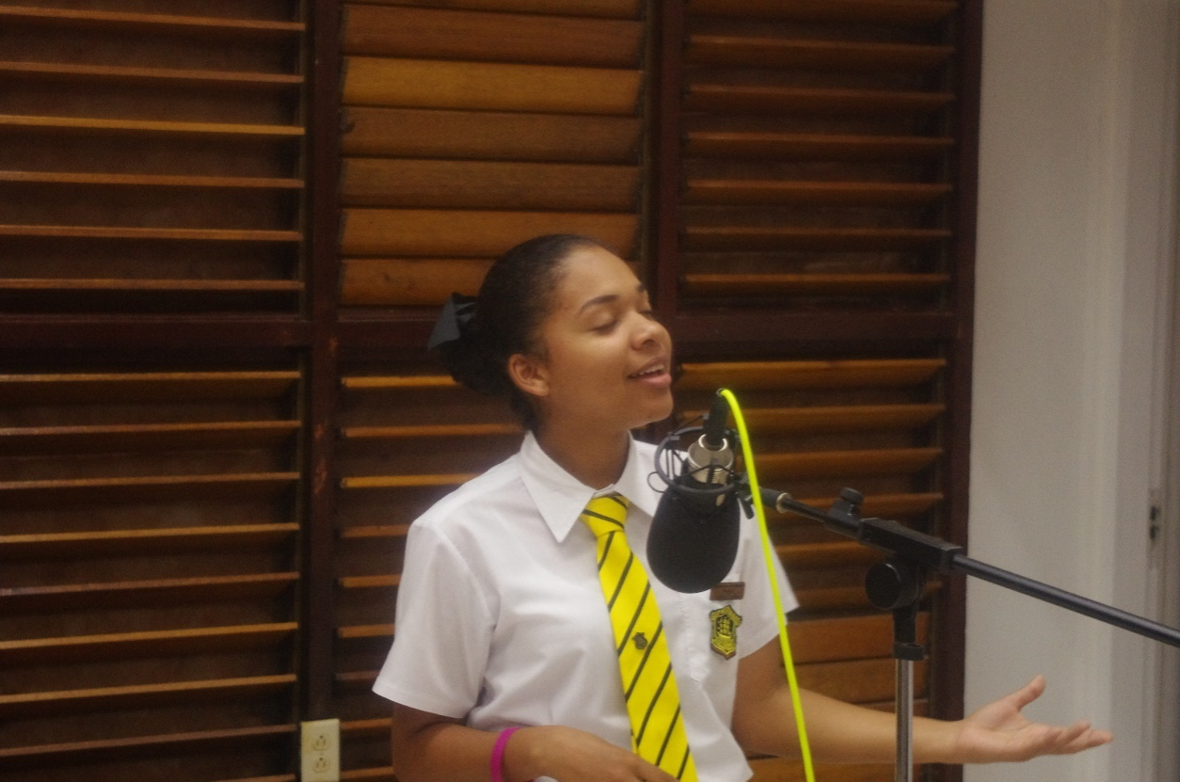***NOTE TO EXAMINER:*** The Animatic is embedded in this PDF below, if unable to play animatic, a copy of it will be included in the file.

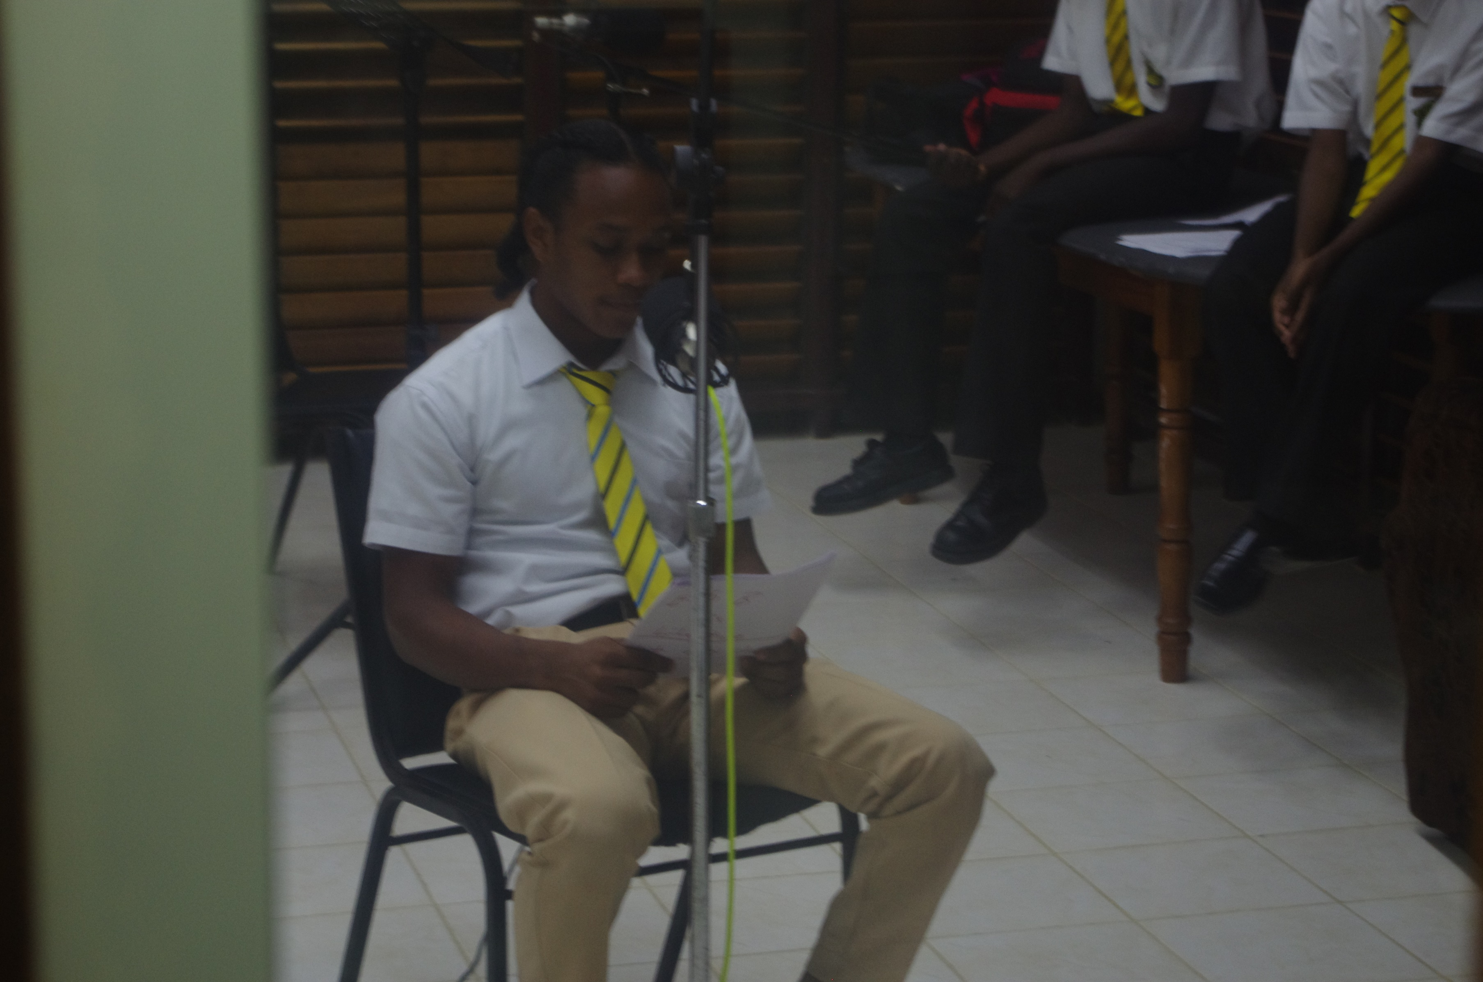



## **PROJECT OUTLINE**

**PROJECT NAME: CRITICAL THINKING TOOL: INTERACTIVE MEDIA JOURNAL**

**Project Overview**

The Interactive Media Journal is an educational tool which contains interactive elements such as videos, pictures, sound and animations to deliver educational content to both students and teachers. Research was conducted to verify and testify the need for this project. The results yielded positive answers showing that students are not motivated to work in class, have a tough time with English literature elements whether in understanding, analysis or synthesis. The project focuses strongly on: the ability to respond to West Indian and other literatures in English: novels, short stories, poems and plays; to make rational and sensitive appraisal of value judgements, states of consciousness and other concepts explored in literature, and to relate these to everyday living. The Objectives of the Interactive Journal are:

* The ability to communicate informed opinions and judgments in well-structured, analytical responses in oral and written form using the vocabulary of literary criticism.
* The provision of quality education to less fortunate students whom cannot attend extra lessons.
* This Journal serves as a platform for Caribbean students to achieve universal secondary education, as the researcher hopes to implement Interactive journals for all subject areas.
* The ability to analyse effectively, poems, plays and other forms of literature, to understand the message of these literature art forms.

**Project Process**

In order to fulfil the scope and objectives of this project, the design of the project would need to interpret them accurately. In doing so, the researchers divided the project into two parts, “The Poems” and a “How to Guide”.

The Interactive Journal comprising of the Poems and How to Guide will be designed and exported with the following specifications:

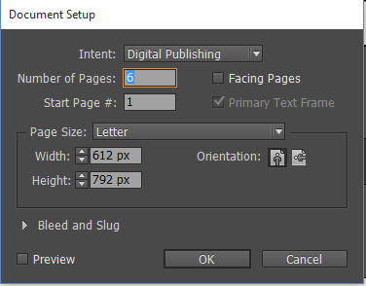

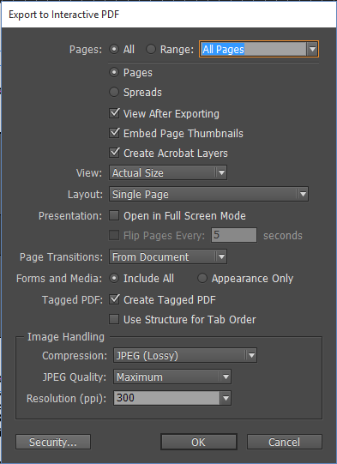

* Designing and developing the Interactive Journal, several constraints were identified such as, the Time factor is a major issue in the development of the project, and this would result in only 3 poems being completed in time for submission, another constraint was in terms of cost, since the cost of production as well as the procurement of materials to design the pictures are costly. The project is slated to take 17 weeks to complete, starting in September 2015 and ending in February 2016. The budget of this project was identified, both income and planned expenditure and this will be used to ensure the production cost would not exceed income. The Literature Journal will be sold for USD 9.99 per copy and available through Adobe Creative Cloud Upload Centre, for the initial 3 months a demo edition will be of a free download to anyone on through a web link. This will be done to promote awareness, receive feedback and gain potential investors.

## **BRAINSTORMING CHART**

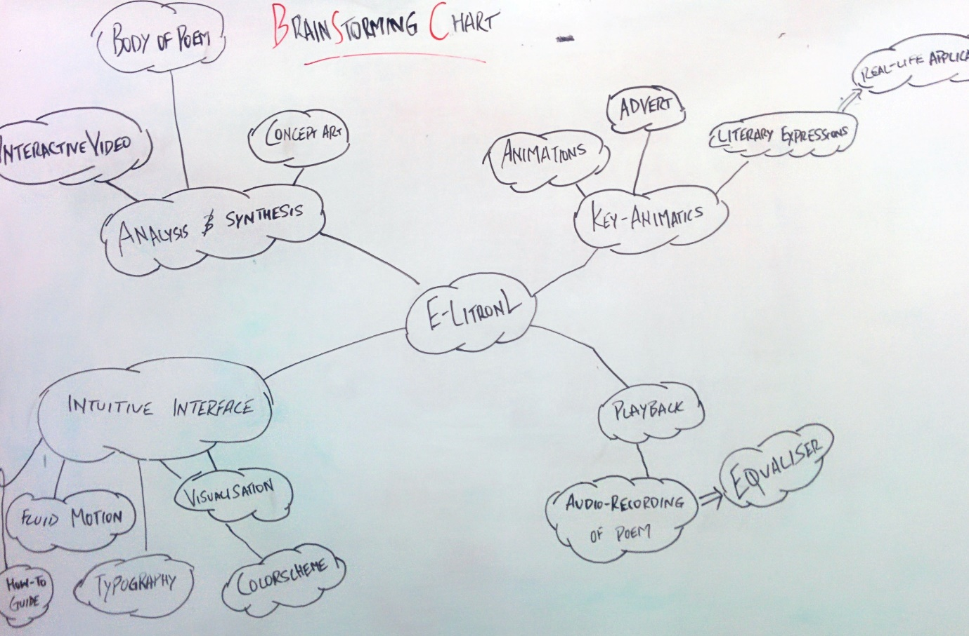

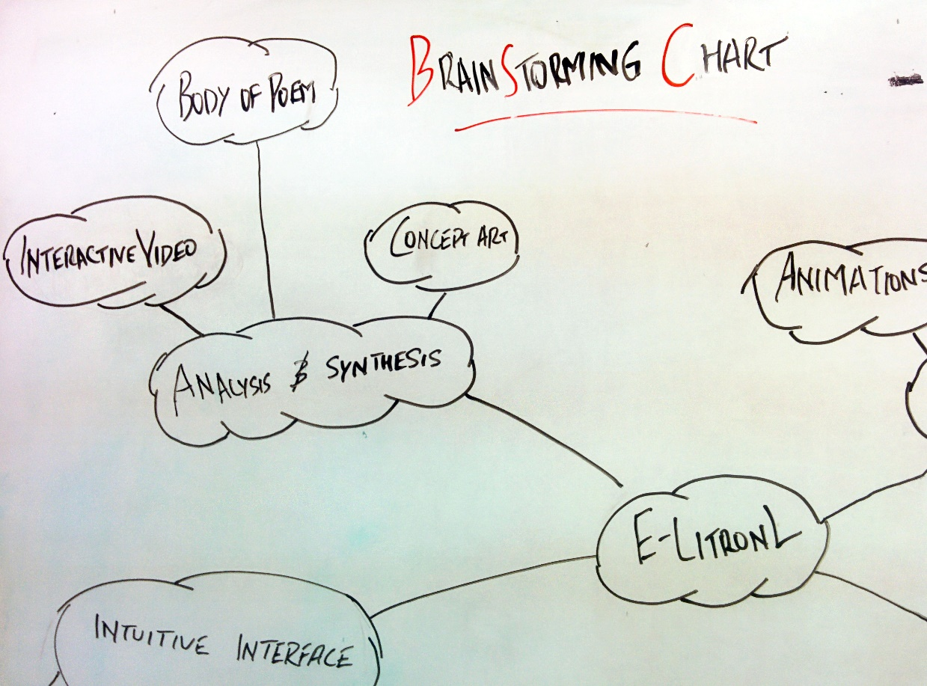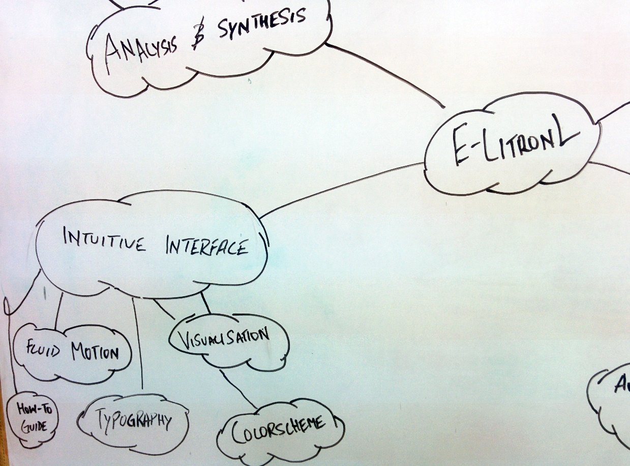

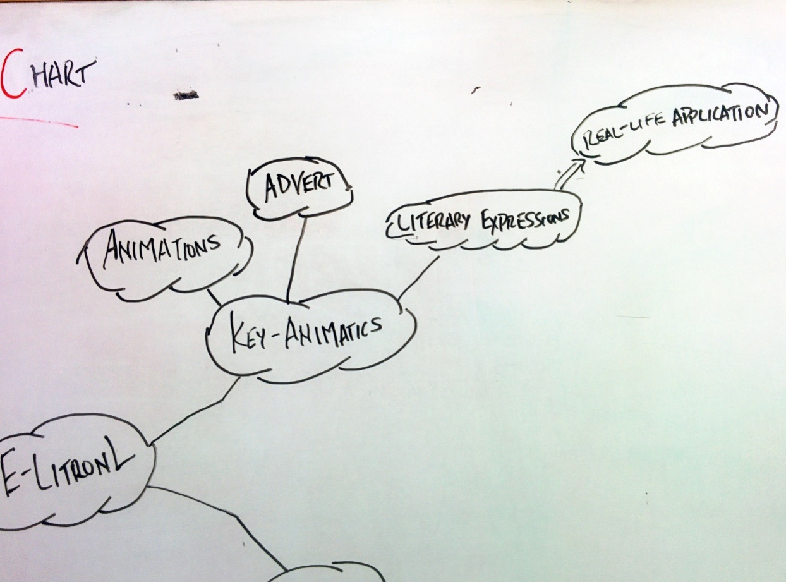

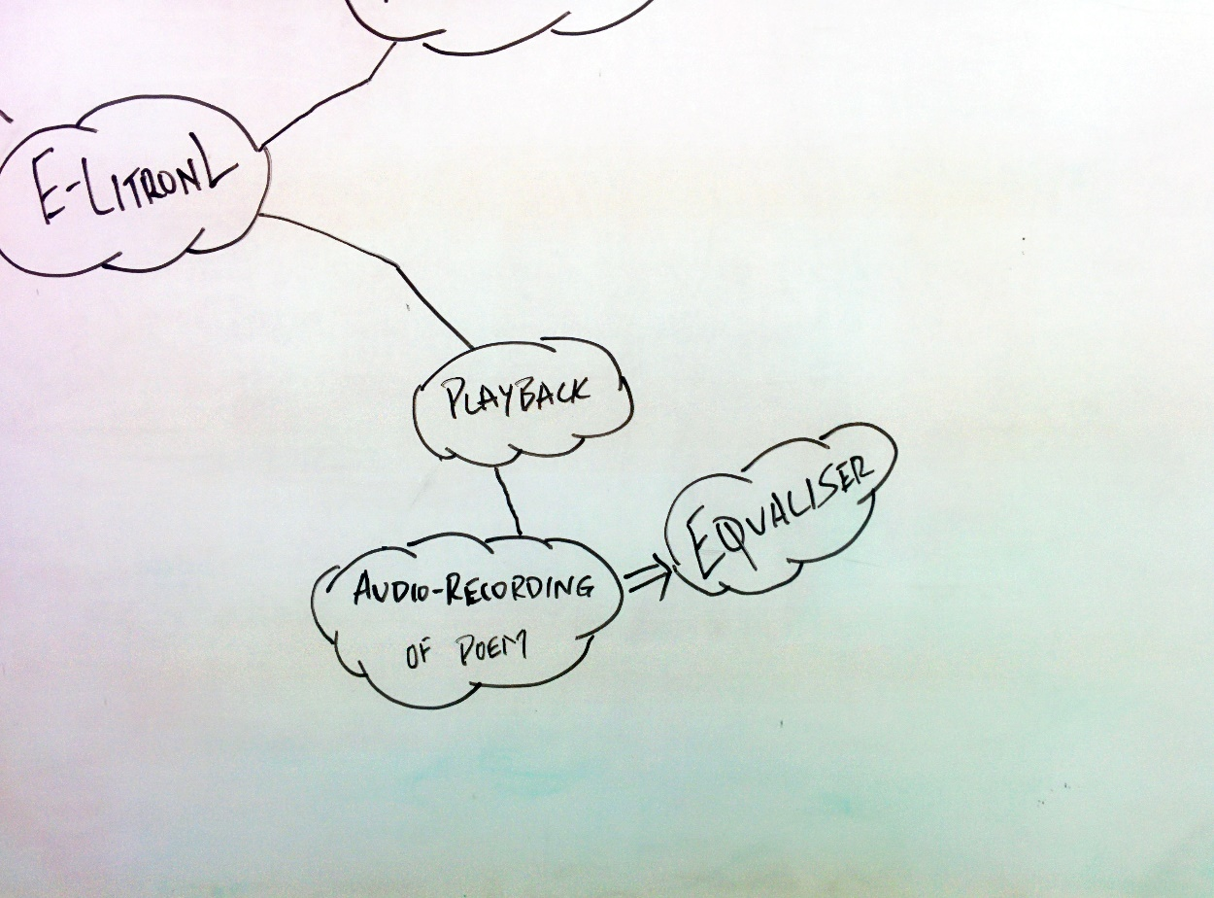

## **FINAL MODELS/ PROPS/ASSETS/FINAL CONTENT**

**Final Content – Concept Art**

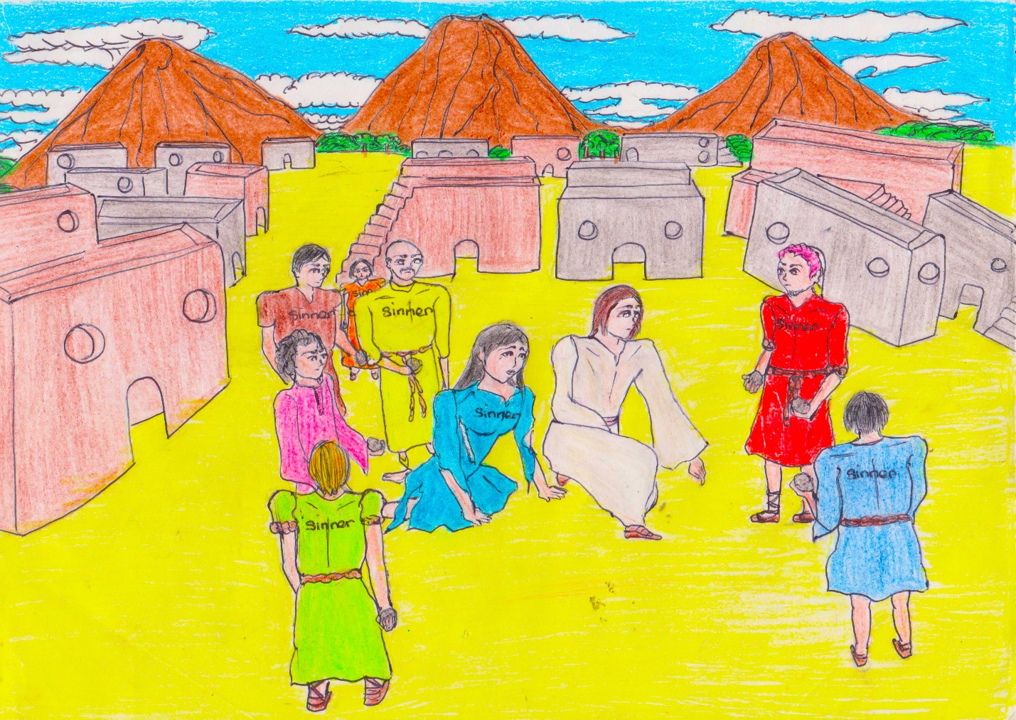

**A Stone’s Throw by Elma Mitchell - Concept Art**

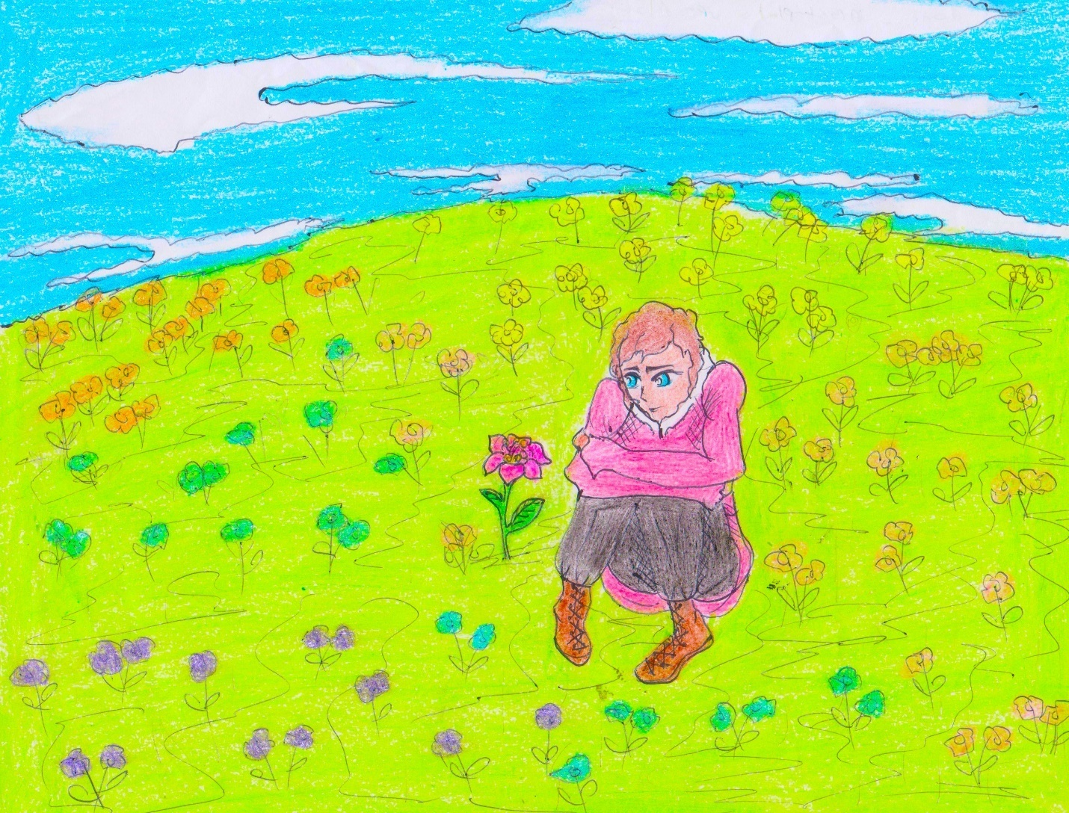

**A Contemplation upon Flowers by Henry King – Concept Art**

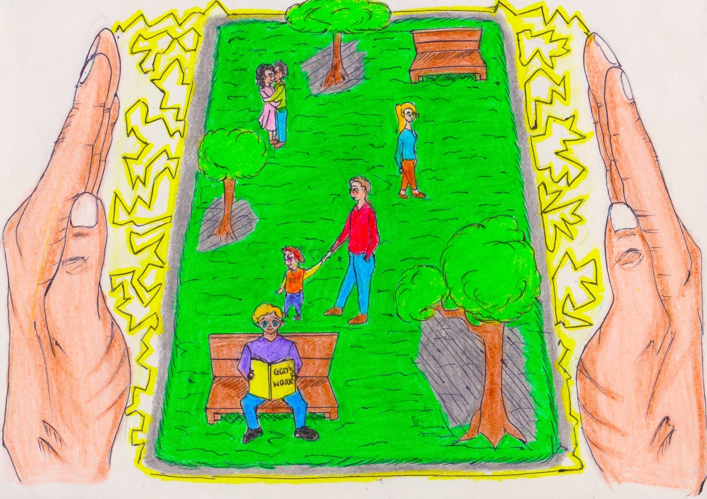

**God’s Grandeur – Concept Art**

## **HYPER TEXT MARK-UP LANGUAGE (HTML) MOCK-UPS**

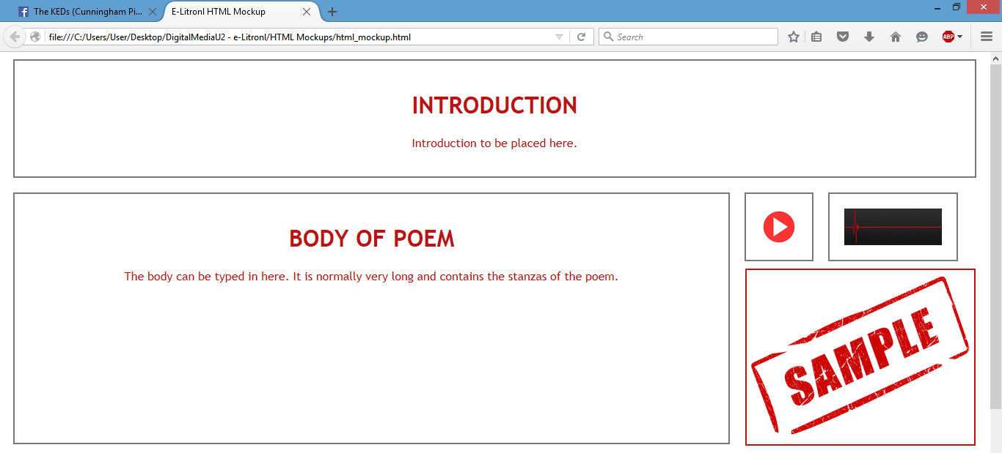

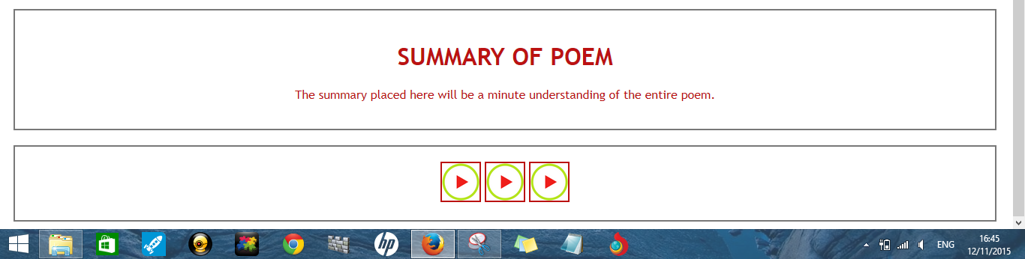

## **HYPER TEXT MARK-UP LANGUAGE (HTML) – Code**

### **CODE**

<html>

<head>

<title>E-Litronl HTML Mockup</title>

<style>

*{

font-family:"Trebuchet MS", Helvetica, sans-serif;color:#bb1212;text-align:center;

}

div{

margin:10px;padding:20px;border:2px solid #787878;position:relative;

}

#poembody{

width:70%;float:left;min-height:300px;

}

#playbutton{

height:50px;width:50px;float:left;

}

#playequalizer{

height:50px;width:10%;float:left;

}

#summary{

width:95%;top:0px;float:left

}

#buttons{

width:95%;top:0px;float:left

}

</style>

</head>

<body>

<div id="intro">

<h1>INTRODUCTION</h1>

<p>Introduction to be placed here.</p>

</div>

<div id="poembody">

<h1>BODY OF POEM</h1>

<p>The body can be typed in here. It is normally very long and contains the stanzas of the poem. </p>

</div>

<div id="playbutton">

<imgsrc="file:///C:/Users/User/Desktop/DigitalMediaU2 - e-Litronl/HTML Mockups/img/audio.png" alt="button" height=50 width=50>

</div>

<div id="playequalizer">

<imgsrc="file:///C:/Users/User/Desktop/DigitalMediaU2 - e-Litronl/HTML Mockups/img/equalizer.jpg" alt="button" height=50 width=100%>

</div>

<imgsrc="file:///C:/Users/User/Desktop/DigitalMediaU2 - e-Litronl/HTML Mockups/img/sample.jpg" width=310px height=238px border=2px>

<div id="summary">

<h1>SUMMARY OF POEM</h1>

<p>The summary placed here will be a minute understanding of the entire poem. </p>

</div>

<div id="buttons">

<imgsrc="file:///C:/Users/User/Desktop/DigitalMediaU2 - e-Litronl/HTML Mockups/img/play.png" alt="button" height=50 width=50 border=2px>

<imgsrc="file:///C:/Users/User/Desktop/DigitalMediaU2 - e-Litronl/HTML Mockups/img/play.png" alt="button" height=50 width=50 border=2px>

<imgsrc="file:///C:/Users/User/Desktop/DigitalMediaU2 - e-Litronl/HTML Mockups/img/play.png" alt="button" height=50 width=50 border=2px>

</div>

</body>

</html>

**USE OF COLLABORATION TOOLS**

**Google Drive –** is a [file storage and synchronization service](https://en.wikipedia.org/wiki/File_hosting_service) created by [Google](https://en.wikipedia.org/wiki/Google). It allows users to [store files in the cloud](https://en.wikipedia.org/wiki/Cloud_storage), [share files](https://en.wikipedia.org/wiki/File_sharing), and [edit documents, spreadsheets, and presentations with collaborators](https://en.wikipedia.org/wiki/Collaborative_editing). The researchers used this service mainly to share content across the internet, as well as to create a virtual space where we can share, upload and download SBA related files.

**Screen Shots of the service in use**

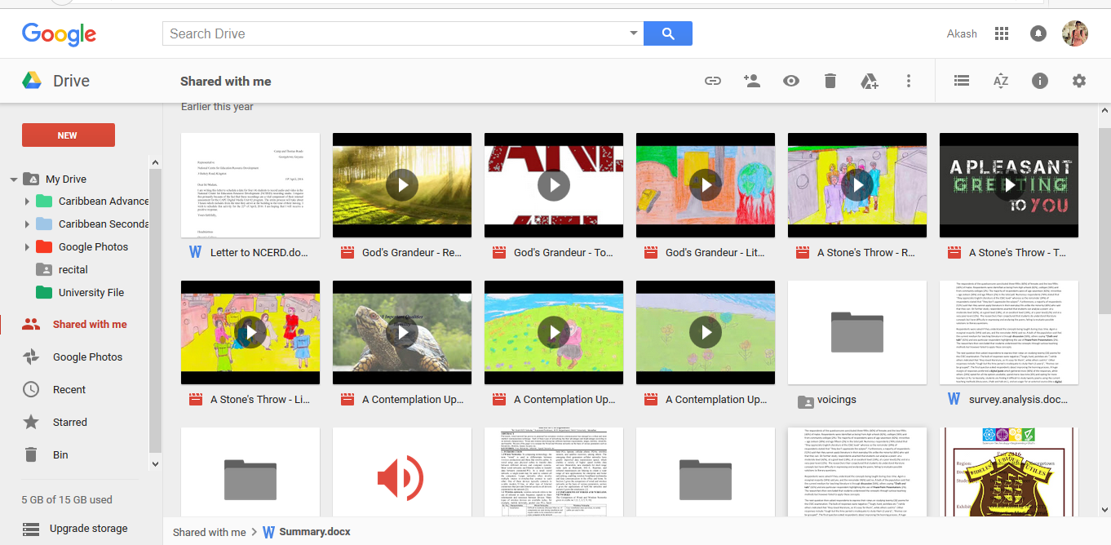

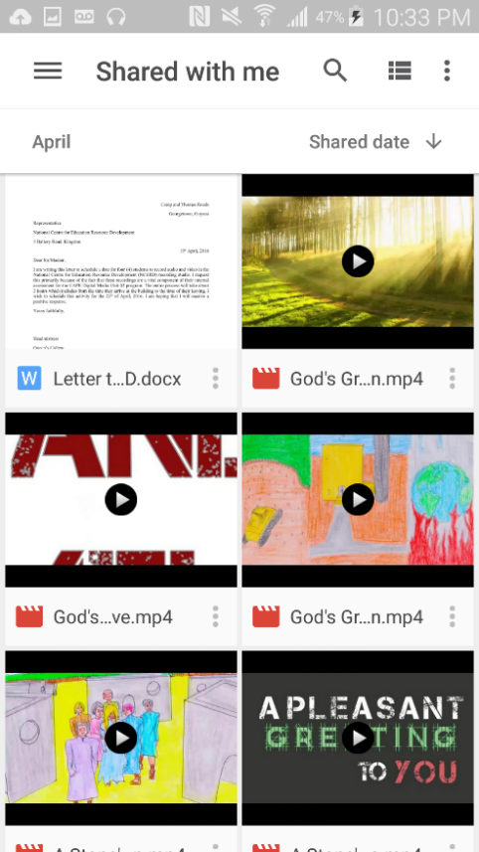

**Note to Examiner:**for validation reasons, if the need arises to access the google Drive folder, copy and paste the following link:

https://drive.google.com/open?id=0B3HgklS7JCwpTERrNHdHUXVwYUk

**Google Docs** is a [word processor](https://en.wikipedia.org/wiki/Word_processor), all part of a free, [web-based](https://en.wikipedia.org/wiki/Web_application) software [office suite](https://en.wikipedia.org/wiki/Office_suite) offered by [Google](https://en.wikipedia.org/wiki/Google) within its [Google Drive](https://en.wikipedia.org/wiki/Google_Drive) service. The suite allows users to create and edit documents online while collaborating with other users in real-time.

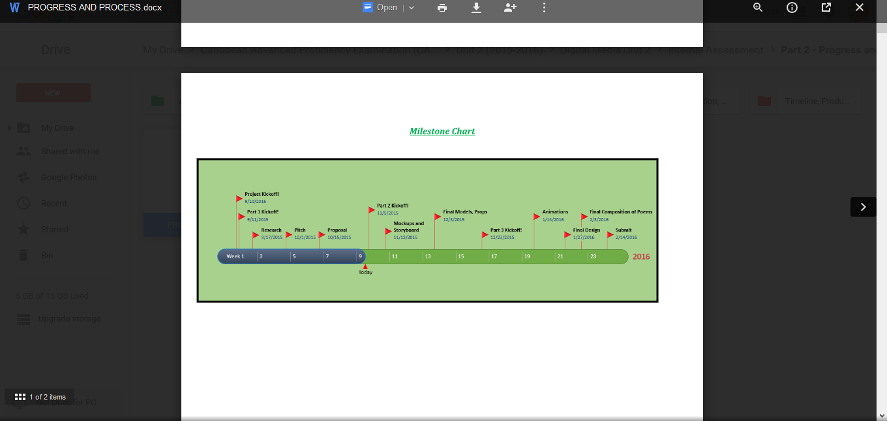

**Google Hangouts** - is a [communication platform](https://en.wikipedia.org/wiki/Communication_software) developed by [Google](https://en.wikipedia.org/wiki/Google) which includes [instant messaging](https://en.wikipedia.org/wiki/Instant_messaging), [video chat](https://en.wikipedia.org/wiki/Videotelephony), [SMS](https://en.wikipedia.org/wiki/SMS) and [VOIP](https://en.wikipedia.org/wiki/VOIP) features. This was used to visually share ideas.

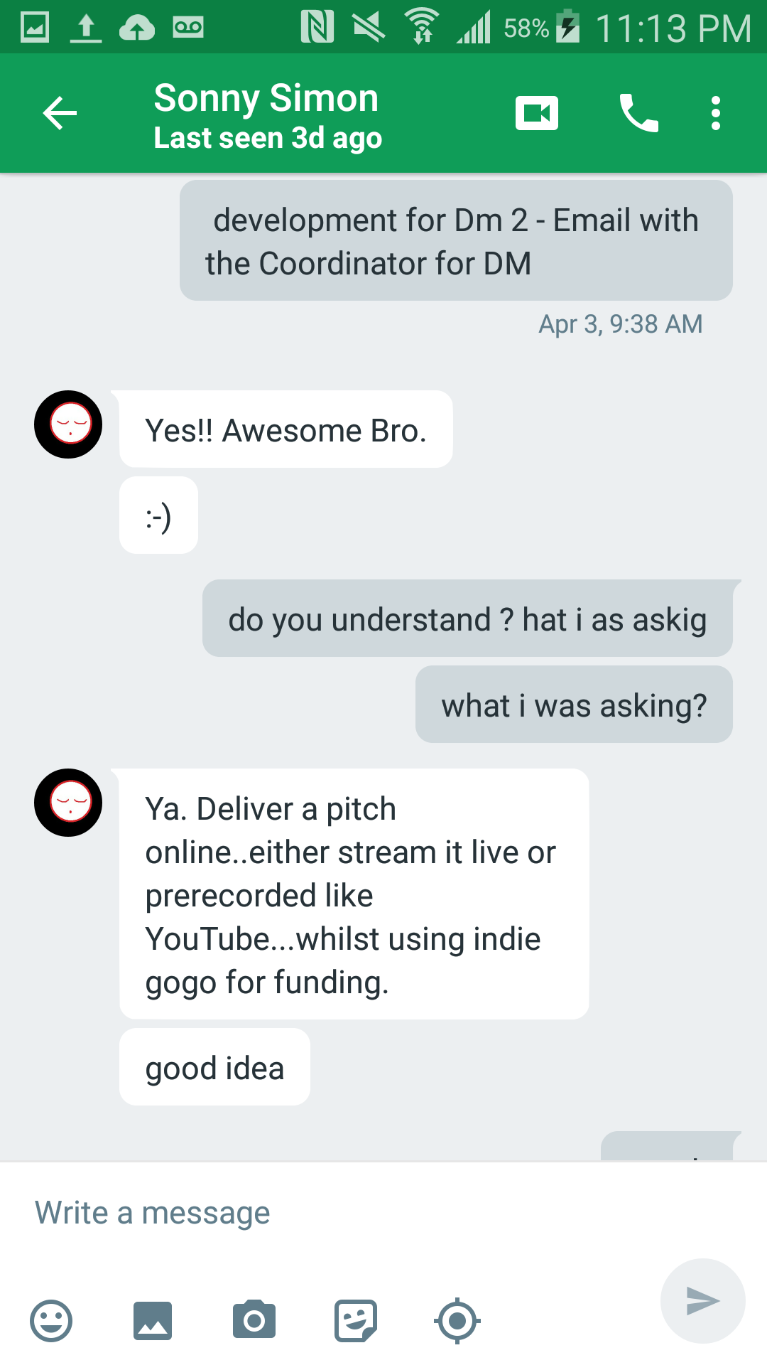

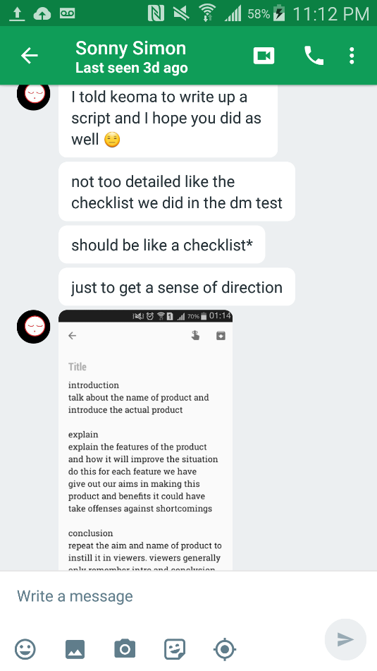

# ***PART 3: PRODUCT***

## **Interactive Product – E-Litronl – A Visualization Entity**

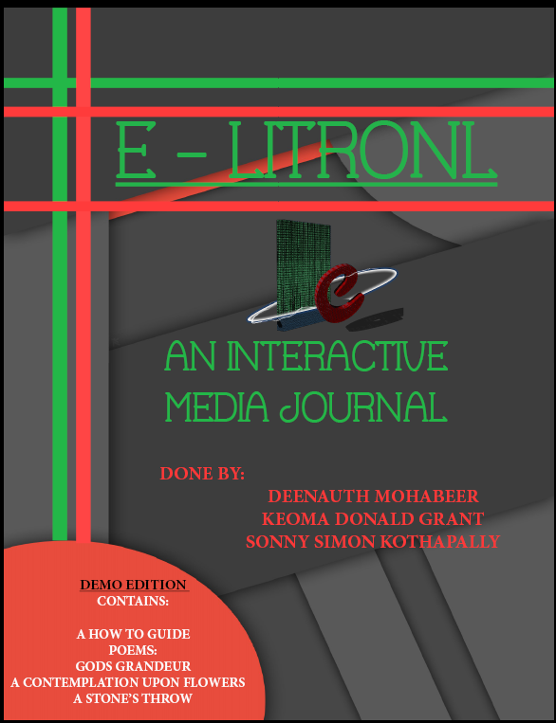

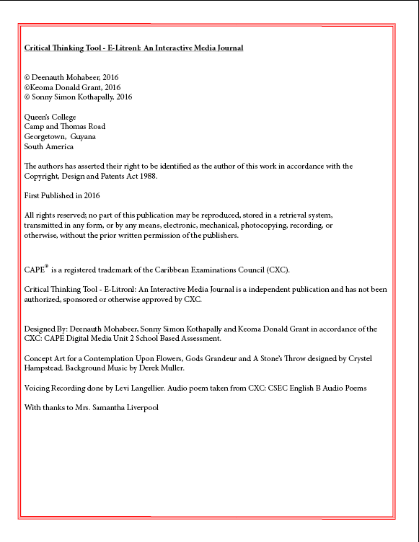

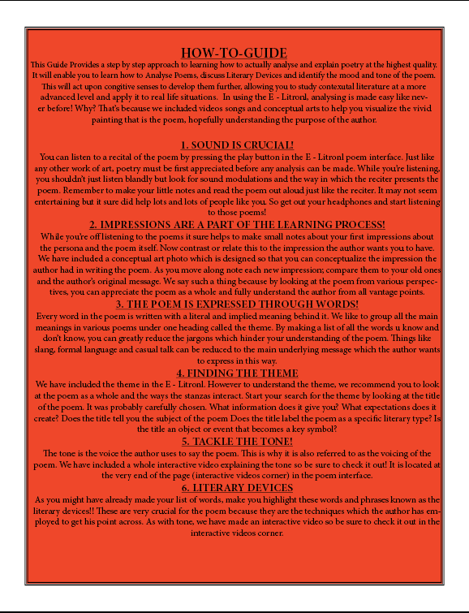



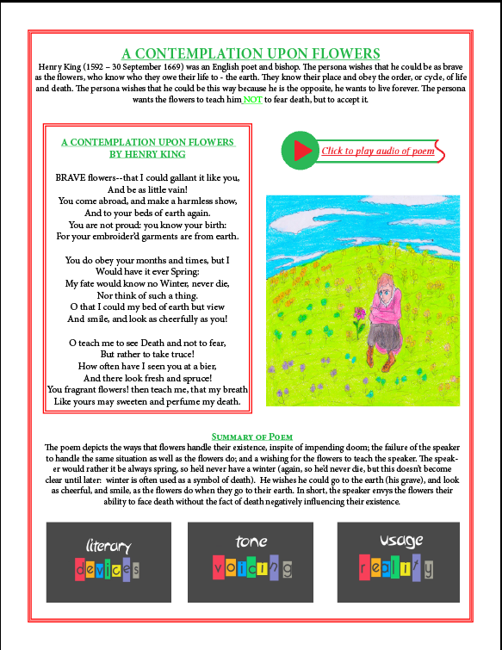

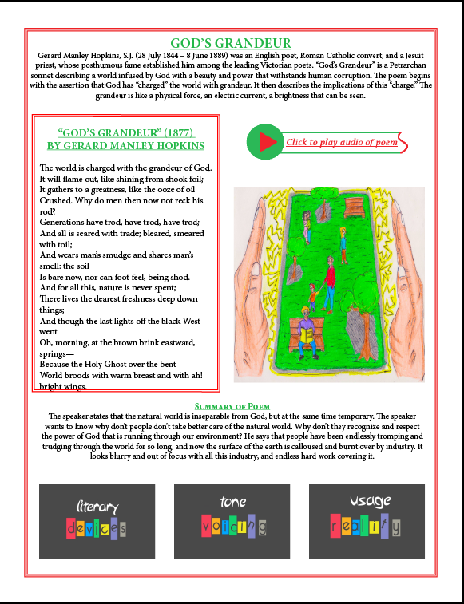

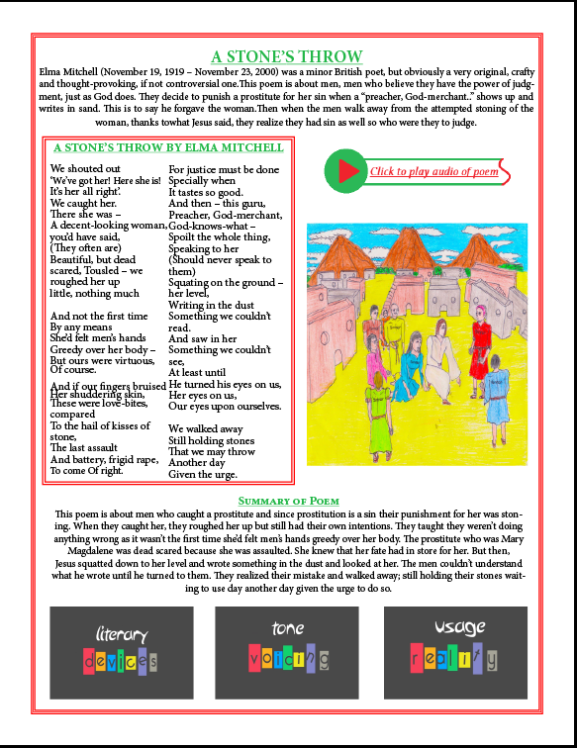

## **GOOD USE OF COLORS AND TEXTURE**

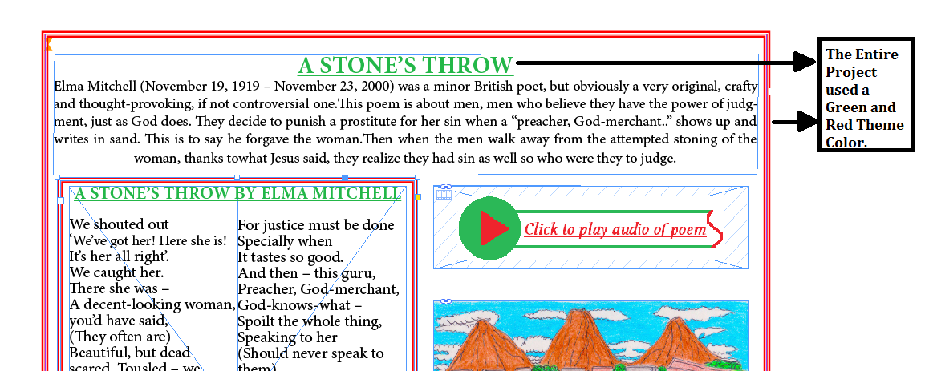

The Entire E-LITRONL product used a colour scheme of Green and Red due to its compatibility and its combined enhanced aesthetics.

## **GOOD USE OF SPACE**

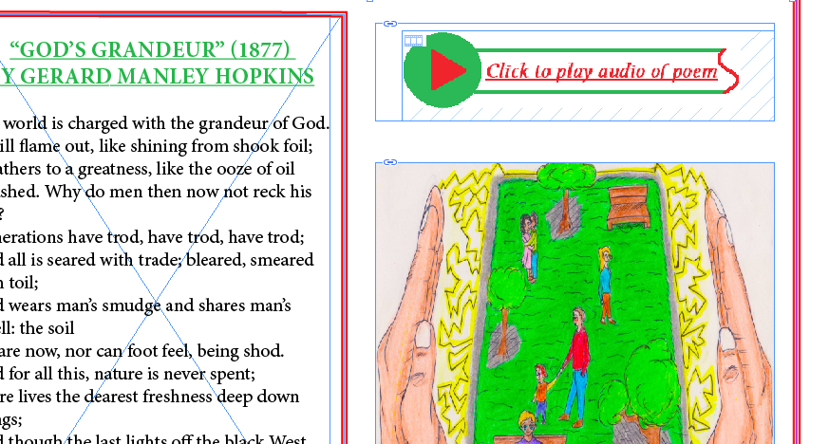

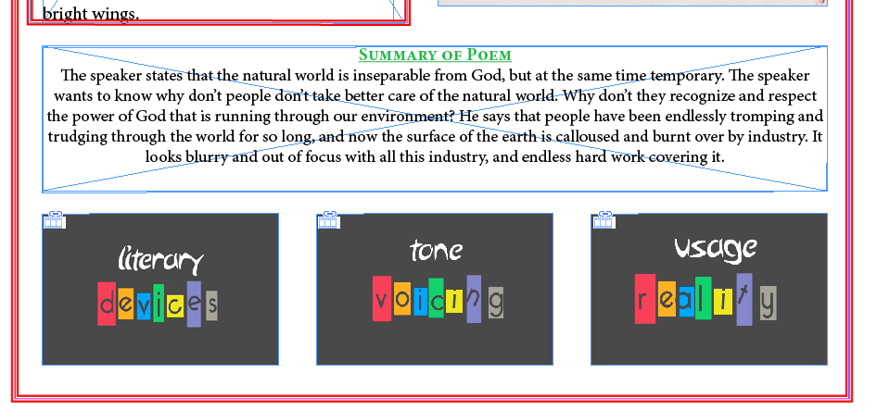

E-Litronl – use of space was imperative for the user experience and deliverance of content, this was done on a proportional and equal basis to facilitate efficient user experience and content positioning.

## **GOOD USE OF TYPOGRAPHY**



Typography was carefully chosen to ensure that it would not inhibit user experience and aesthesis design. Typography used was Minion Pro and font size varied with Headings set at 18 and content at 12.

## **BIBLIOGRAPHY**

Yue-Ling, W. (2008). *Digital Media Primer* (1st ed., Vol. 1). Pearson Education.

Yue-Ling, W. (2009). *Instructor Resources to accompany Digital Media Primer* (1st ed., Vol. 1). Prentice Hall